A PROJECT REPORT ON

XXXXXXXXXX

Submitted to Osmania University for the partial fulfillment of the
requirement for the

Award of Degree for

XXXXXXXXXXXXXXXXXXXXXXXX

Done by

Mr. /Miss. XXXXXX

XXXXX Institute of Management & Computer Sciences
Hyderabad

CERTIFICATE

This is to certify that Mr. XXXX, bearing Roll No. XXXXXXXXXXX have developed Software project titled XXXXXXXX for xxx SOFTWARE SOLUTIONS as a partial Fulfillment for the award of the Degree of XXXXXXX.

HEAD OF DEPARTMENT PRINCIPAL
XXX institute of Management &
Computer Sciences

EXTERNAL

ACKNOWLEDGMENT

My express thanks and gratitude and thanks to Almighty God, my parents and other family members and friends without whose uncontained support, I could not have made this career in XXXX.

I wish to place on my record my deep sense of gratitude to my project guide, Mr. XXXXX, xxx Software Solutions, Hyderabad for his constant motivation and valuable help through the project work. Express my gratitude to Mr. XXXX, Director of XXXXX Institute of Management & Computer Sciences for his valuable suggestions and advices through out the XXX course. I also extend my thanks to other Faculties for their Cooperation during my Course.

Finally I would like to thank my friends for their cooperation to complete this project.

XXXXXXX

ABSTRACT

This project is mainly developed for the communication of Employees of organization located at different locations. The project entitled “Live Meeting” set of platform for the project leaders and administrator to send messages to keep constant interaction with the programmers.

In the proposed system, the administrator can communicate with the project leaders and programmers and can also maintain the login time and logout time. He can chat about the project going on with both the programmers and project leaders. This project also maintains offline messages. The project leader gives the instant report about the project to the administrator.

Through this Communication System, Whenever user logs-in into the system then login time is recorded in the administrator’s system automatically. The administrator can scan the present online users and send the messages to single programmer ,set of programmers, project leader or Set of project leaders or all the employees wherever he/ she is present.
This project makes the most of the tedious and mundane deskwork to minimize. This facilitates the user to concentrate more on the project and less on the managing of these tasks.

The software is fully integrated with CRM (Customer Relationship Management) as well as CMS (Content Management System) solution and developed in a manner that is easily manageable, time saving and relieving one from manual works.

The proposed system maintains…
- Frequent interaction between the administrator and the project leaders/programmers.
- Automatically recording the login time/logout time of the user.
- Maintaining on line and offline Messages and Message View
- Employee Hierarchical

Functional components of the project: Following is a list of functionality of the system:

- MESSAGE SENDING: In the large organization there are a set of programmers, Project leader and Administrator. These programmers are spread through out the organization into various groups. Project Leaders are in need to constantly interact with the programmer’s in-groups spread over organization. It is difficult to go and pass the message to each and ever programmer in personal
- CHATTING: When a person wants directly to communicate with the colleague, he/she can use this service. If a person is in online that person can communicate with the other person through the system located at different location.
- VIEW MESSAGES: This project consists of both online/offline messages. if the user is online he can directly interact with the other user. If the user is in offline he can view the message when he logins for the next time.
- EMPLOYEE HIERACHIAL: This project maintains hierarchy for the employees.

ADMINISTRATOR

PROJECT LEADER

PROGRAMMERS
- LOGIN DATE/TIME: When the user logins the system, the login time is automatically recorded.
- LOGOUT DATE/TIME: When the user logouts the system, the logout time is automatically recorded.
These Login and Logout time are monitored by the administrators/project leaders depending upon the hierarchy.

CONTENTS

- INTRODUCTION

INTRODUCTION TO PROJECT
ORGANIZATION PROFILE
PURPOSE OF THE PROJECT
PROBLEM IN EXISTING SYSTEM
SOLUTION OF THESE PROBLEMS

- SYSTEM ANALYSIS

  - INTRODUCTION
  - SYSTEM WORKFLOW
  - STUDY OF THE SYSTEM
  - HARDWARE & SOFTWARE REQUIRMENT
  - PROPOSED SYSTEM
  - INPUT & OUTPUT
  - PROCESS MODELS USED WITH JUSTIFICATION

- FEASIBILITY REPORT

  - TECHNICAL FEASIBILITY
  - OPERATIONAL FEASIBILITY
  - ECONOMIC FEASIBILITY

- SOFTWARE REQUIREMENT SPECIFICATIONS

  - FUNCIONAL REQUIREMENTS
  - PERFORMANCE REQUIREMENTS

- SELECTED SOFTWARE

  - INTRODUCTION TO .NET FRAMEWORK
  - ASP.NET
  - C#.NET
  - SQL SERVER

- SYSTEM DESIGN

  - INTRODUCTION
  - SYSTEM WORKFLOW
  - NORMALIZATION
  - E-R DIAGRAM
  - DATA FLOW DIAGRAMS
  - DATA DICTIONARY

- OUTPUT SCREENS

- SYSTEM TESTING AND IMPLEMENTATION

  - INTRODUCTION
  - STRATEGIC APPROACH OF SOFTWARE TESTING
  - UNIT TESTING
  - TEST

- SYSTEM SECURITY

9.1. INTRODUCTION
  - SECURITY IN SOFTWARE

- CONCLUSION

- FUTURE IMPROVEMENT

- BIBLIOGRAPHY

Chapter 1

INTRODUCTION

1.1. INTRODUCTION TO PROJECT
This project is mainly developed for the communication of Employees of organization located at different locations. The project entitled “Live Meeting” set of platform for the project leaders and administrator to send messages to keep constant interaction with the programmers.

In the proposed system, the administrator can communicate with the project leaders and programmers and can also maintain the login time and logout time. He can chat about the project going on with both the programmers and project leaders. This project also maintains offline messages. The project leader gives the instant report about the project to the administrator.

Through this Communication System, Whenever user logs-in into the system then login time is recorded in the administrator’s system automatically. The administrator can scan the present online users and send the messages to single programmer ,set of programmers, project leader or Set of project leaders or all the employees wherever he/ she is present.
This project makes the most of the tedious and mundane deskwork to minimize. This facilitates the user to concentrate more on the project and less on the managing of these tasks.

The software is fully integrated with CRM (Customer Relationship Management) as well as CMS (Content Management System) solution and developed in a manner that is easily manageable, time saving and relieving one from manual works.

The proposed system maintains…
- Frequent interaction between the administrator and the project leaders/programmers.
- Automatically recording the login time/logout time of the user.
- Maintaining on line and offline Messages and Message View
- Employee Hierarchical

  - ORGANIZATION PROFILE

SOFTWARE SOLUTIONS

xxx Software Solutions is an IT solution provider for a dynamic environment where business and technology strategies converge. Their approach focuses on new ways of business combining IT innovation and adoption while also leveraging an organization’s current IT assets. Their work with large global corporations and new products or services and to implement prudent business and technology strategies in today’s environment.

XXX’S RANGE OF EXPERTISE INCLUDES:
- Software Development Services
- Engineering Services
- Systems Integration
- Customer Relationship Management
- Product Development
- Electronic Commerce
- Consulting
- IT Outsourcing
We apply technology with innovation and responsibility to achieve two broad objectives:
- Effectively address the business issues our customers face today.
- Generate new opportunities that will help them stay ahead in the future.

THIS APPROACH RESTS ON:
- A strategy where we architect, integrate and manage technology services and solutions - we call it AIM for success.
- A robust offshore development methodology and reduced demand on customer resources.
- A focus on the use of reusable frameworks to provide cost and times benefits.
They combine the best people, processes and technology to achieve excellent results - consistency. We offer customers the advantages of:

SPEED:
They understand the importance of timing, of getting there before the competition. A rich portfolio of reusable, modular frameworks helps jump-start projects. Tried and tested methodology ensures that we follow a predictable, low - risk path to achieve results. Our track record is testimony to complex projects delivered within and evens before schedule.

EXPERTISE:
Our teams combine cutting edge technology skills with rich domain expertise. What’s equally important - they share a strong customer orientation that means they actually start by listening to the customer. They’re focused on coming up with solutions that serve customer requirements today and anticipate future needs.

A FULL SERVICE PORTFOLIO:
They offer customers the advantage of being able to Architect, integrate and manage technology services. This means that they can rely on one, fully accountable source instead of trying to integrate disparate multi vendor solutions.

SERVICES:
Xxx is providing it’s services to companies which are in the field of production, quality control etc With their rich expertise and experience and information technology they are in best position to provide software solutions to distinct business requirements.

  - PURPOSE OF THE PROJECT

This project is mainly developed for the communication of Employees of organization located at different locations. The project entitled “Live Meeting” set of platform for the project leaders and administrator to send messages to keep constant interaction with the programmers.

In the proposed system is the administrator can sit at his system and communicate with the project leaders, programmers and can also maintain the login time, logout time. He can chat about the project going on with both the programmers and project leaders. This project also maintains offline messages. The administrator sees the IP address of the system of project leader/programmer he is interested and chat with the people .The project leader gives the instant report about the project to the administrator.

Through this Communication System, Whenever user logs-in into the system then login time is recorded in the administrator’s system automatically. The administrator can scan the present online system IP Address and send the messages to single programmer ,set of programmers, project leader or Set of project leaders or all the employees where he/ she is present.
This project makes the most of the tedious and mundane deskwork to minimize. This facilitates the user to concentrate more on the project and less on the managing of these tasks.

The proposed system maintains…
- Frequent interaction between the administrator and the project leaders/programmers.
- Automatically recording the login time/logout time of the user.
- Maintaining on line and offline Messages and Message View
- Employee Hierarchical

  - PROBLEM IN EXISTING SYSTEM

The existing system is manual system. Needs to be converted into automated system. Risk of mismanagement of data. Less Security. No proper coordination between different Applications and Users. Fewer Users - Friendly. Accuracy not guaranteed. Not in reach of distant users. Communication between users through phone or manually.
The existing system users are using third party public mail services for communication. Using public domains are not supposed for employee communication.
Anonymous user can be allowed like these public domains. It is critical to share their information like this environment. Some organizations are using manual system. In the manual system the data can be stored and transferred in the form of disk drives or paper.
Semi automated systems are connected through LAN but they are using data in local systems like Ms-Access or MS-Excel etc. In local data base there is no Option for data security and data integrity.

  - PROPOSED SYSTEM

The development of the new system contains the following activities, which try to automate the entire process keeping in view of the database integration approach.
User friendliness is provided in the application with various controls. The system makes the overall project management much easier and flexible. There is no risk of data mismanagement at any level while the project development is under process. It provides high level of security with different level of authentication. Users from any part of the world can make use of the system. New system will process accurate results. New system will be much better in performance as compared to existing one.
The proposed system is having frequent interaction between administrator and the project members by using email and chat modules.

Chapter 2

SYSTEM ANALYSIS

2.1. INTRODUCTION
After analyzing the requirements of the task to be performed, the next step is to analyze the problem and understand its context. The first activity in the phase is studying the existing system and other is to understand the requirements and domain of the new system. Both the activities are equally important, but the first activity serves as a basis of giving the functional specifications and then successful design of the proposed system. Understanding the properties and requirements of a new system is more difficult and requires creative thinking and understanding of existing running system is also difficult, improper understanding of present system can lead diversion from solution.
2.2. ANALYSIS MODEL
The model that is basically being followed is the WATER FALL MODEL, which states that the phases are organized in a linear order. First of all the feasibility study is done. Once that part is over the requirement analysis and project planning begins. If system exists one and modification and addition of new module is needed, analysis of present system can be used as basic model.
The design starts after the requirement analysis is complete and the coding begins after the design is complete. Once the programming is completed, the testing is done. In this model the sequence of activities performed in a software development project are: -
- Requirement Analysis
- Project Planning
- System design
- Detail design
- Coding
- Unit testing
- System integration & testing

Here the linear ordering of these activities is critical. End of the phase and the output of one phase is the input of other phase. The output of each phase is to be consistent with the overall requirement of the system. Some of the qualities of spiral model are also incorporated like after the people concerned with the project review completion of each of the phase the work done.
WATER FALL MODEL was being chosen because all requirements were known beforehand and the objective of our software development is the computerization/automation of an already existing manual working system.

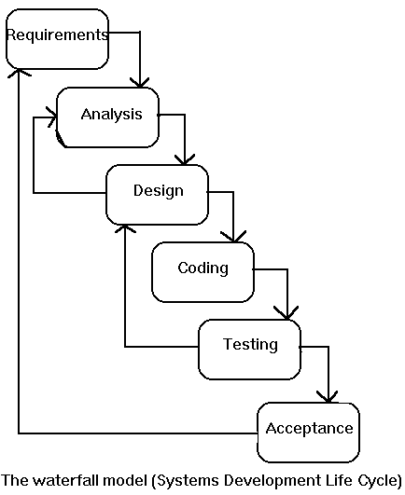

2.3. STUDY OF THE SYSTEM
The Live Meeting Project is mainly based on online chat features with other features like (Member registration feature/ Sending and Receiving mails feature/ Integrated Security feature etc.).
Developing a chat application:
There are different ways to implement a chat application.
In ASP.Net, there are two ways in which we can develop a chat application.
HTML Chat
First one is the HTML chat, where in the chat application is developed using web forms and based on the request response model i.e. the client will keep pinging to the server to check any messages are there for that person, and if we have to send any message, simply post it to the server. In this case the page which provides the chat web form have to be refreshed every time (which is configurable), and will not be a good experience for the user. But regarding the security perspective, this method will be the most matching.
Windows Chat
The second asp.net chat option is to create an Activex control, and plug in to the page so that it implements any of the chat protocols in sync with the chat server .Here we have to create a chat server as some windows service, using Sockets. So that the Activex and the chat server can talk with each of them through some predefined chat protocol or user can define his own custom chat protocol. This will provide better chatting facilities and the web page in which the chat client resides need not be refreshed. Here since we are using Activex, some sort of security problems may arise.
These are the two methods, where in we can develop chat application in .net. The Activex control in the second method can be modified to develop a windows application i.e. a chat Messenger sort of application.

Number of Modules
The system after careful analysis has been identified to be presented with the following modules:

The modules involved are:
- Online Chat Module:
- Registered members are allowed to chat with other registered members. Member needs to be authenticated before entering to chat window. Chatting feature is available in 2 ways :
  - (Single Mode) where 1 member can chat with another member.
  - (Group Mode) where n members can chat with each other.
- Member registration Module:
- Member can register and sign in here. For registration, member has to provide personal details, address details, employment details, account details and they have to agree with policies.
- Member can sign in by providing their account details (Username and password).
- Sending and Receiving mails:
- By making use of this module, Members can send/receive/view mails. Many features have been provided to members so that they can 1) manage (view/ edit/ delete) their mails, 2) forward mails, 3) send attachments, 4) send group mail, manage mails in folders etc.
- Integrated Security Module:
- This module is made is provide security features to the application.
- Admin Module:
- Admin is a super user and hence responsible for a) Site Maintenance, b) Members Management, c) Mails management and d) Generate various reports.

Entities Involved in the Project:
- Users
- Roles
- Mail Message
- Chat Message
- Message Status

Users: Users are employees of the organization. Users are involved in chatting & sending messages.

Roles: Roles are used to classify different types of Users such as Admin, Project managers, Team Leaders, Software Engineers etc.

Mail Message: A Mail Message is used to handle messages sent by users. This will be saved in user’s mailbox.

Chat Message: A Chat Message is sent & received by users in chatting. This message will lose after chatting.
Message Status: Message Status tells status of mail message such as Read, Unread, and Deleted etc.
PROJECT INSTRUCTIONS:
- Based on the given requirements, conceptualize the Solution Architecture. Choose the domain of your interest otherwise develop the application for ultimatedotnet.com. Depict the various architectural components, show interactions and connectedness and show internal and external elements. Design the web services, web methods and database infrastructure needed both and client and server.
- Provide an environment for upgradation of application for newer versions that are available in the same domain as web service target.
2.4. HARDWARE SPEDIFICATIONS
HARDWARE REQUIREMENTS:

- PIV 2.8 GHz Processor and Above
- RAM 512MB and Above
- HDD 20 GB Hard Disk Space and Above

SOFTWARE REQUIREMENTS:

- WINDOWS OS (XP / 2000 / 200 Server / 2003 Server)
- Visual Studio .Net 2005 Enterprise Edition
- Internet Information Server 5.0 (IIS)
- Visual Studio .Net Framework (Minimal for Deployment)
- SQL Server 2000 Enterprise Edition

2.5. PROPOSED SYSTEM

In the proposed system is the administrator can sit at his system and communicate with the project leaders, programmers and can also maintain the login time, logout time. He can chat about the project going on with both the programmers and project leaders. This project also maintains offline messages. The administrator sees the IP address of the system of project leader/programmer he is interested and chat with the people .The project leader gives the instant report about the project to the administrator.

NEED FOR COMPUTERIZATION

We all know the importance of computerization. The world is moving ahead at lightening speed and every one is running short of time. One always wants to get the information and perform a task he/she/they desire(s) within a short period of time and too with amount of efficiency and accuracy. The application areas for the computerization have been selected on the basis of following factors:

- Minimizing the manual records kept at different locations.
- There will be more data integrity.
- Facilitating desired information display, very quickly, by retrieving information from users.
- Facilitating various statistical information which helps in decision-making?
- To reduce manual efforts in activities that involved repetitive work.
- Updating and deletion of such a huge amount of data will become easier.

FUNCTIONAL FEATURES OF THE MODEL

As far as the project is developed the functionality is simple, the objective of the proposal is to strengthen the functioning of Audit Status Monitoring and make them effective and better. The entire scope has been classified into five streams knows as Coordinator Level, management Level, Auditor Level, User Level and State Web Coordinator Level. The proposed software will cover the information needs with respect to each request of the user group viz. accepting the request, providing vulnerability document report and the current status of the audit.

WORKING OF THE SYSTEM
The entire scope has been classified into five streams known as: -
Coordinator Level
(Addressing the information management needs of coordinator)
Management Level
(Addressing the information management needs of management)
Auditor Level
(Addressing the information management needs of auditors)
User Level
(Addressing the information management needs of the user group)
State Web Coordinator level
(Addressing the needs of coordinator of the state)

2.6. INPUT AND OUTPUT

The main inputs, outputs and major functions of the system are as follows
INPUTS:
The main inputs, outputs and major functions of the system are as follows.
Inputs:
Member Registration details:
Registration module is responsible for member registration and login. While registration, member will be prompted for his 1) login account details (username, password, hint question, answer), 2) his personal details, 3) his contact address, 4) his company profile etc. At time of sign in, Member has to provide username and password. In Message compose box, Member has to provide Message to send with Email-ID (to whom message has to be sent.). In the chat window, Member has to provide messages.

OUTPUTS:
- On successful registration, member will be provided confirmation mail.
- On successful signing in, member will be placed to his Account page.
- In Chat window, Member will be getting messages sent by other members.

2.7. PROCESS MODELS USED WITH JUSTIFICATION

ACCESS CONTROL FOR DATA WHICH REQUIRE USER AUTHENTICATION

The following commands specify access control identifiers and they are typically used to authorize and authenticate the user (command codes are shown in parentheses)

USER NAME (USER)

The user identification is that which is required by the server for access to its file system. This command will normally be the first command transmitted by the user after the control connections are made (some servers may require this).

PASSWORD (PASS)

This command must be immediately preceded by the user name command, and, for some sites, completes the user's identification for access control. Since password information is quite sensitive, it is desirable in general to "mask" it or suppress type out.

Chapter 3

Feasibility Report

Preliminary investigation examine project feasibility, the likelihood the system will be useful to the organization. The main objective of the feasibility study is to test the Technical, Operational and Economical feasibility for adding new modules and debugging old running system. All system is feasible if they are unlimited resources and infinite time. There are aspects in the feasibility study portion of the preliminary investigation:
- Technical Feasibility
- Operation Feasibility
- Economical Feasibility

3.1. Technical Feasibility
The technical issue usually raised during the feasibility stage of the investigation includes the following:
- Does the necessary technology exist to do what is suggested?
- Do the proposed equipments have the technical capacity to hold the data required to use the new system?
- Will the proposed system provide adequate response to inquiries, regardless of the number or location of users?
- Can the system be upgraded if developed?
- Are there technical guarantees of accuracy, reliability, ease of access and data security?

Earlier no system existed to cater to the needs of ‘Secure Infrastructure Implementation System’. The current system developed is technically feasible. It is a web based user interface for audit workflow at NIC-CSD. Thus it provides an easy access to the users. The database’s purpose is to create, establish and maintain a workflow among various entities in order to facilitate all concerned users in their various capacities or roles. Permission to the users would be granted based on the roles specified. Therefore, it provides the technical guarantee of accuracy, reliability and security. The software and hard requirements for the development of this project are not many and are already available in-house at NIC or are available as free as open source. The work for the project is done with the current equipment and existing software technology. Necessary bandwidth exists for providing a fast feedback to the users irrespective of the number of users using the system.

3.2. Operational Feasibility
Proposed projects are beneficial only if they can be turned out into information system. That will meet the organization’s operating requirements. Operational feasibility aspects of the project are to be taken as an important part of the project implementation. Some of the important issues raised are to test the operational feasibility of a project includes the following: -
- Is there sufficient support for the management from the users?
- Will the system be used and work properly if it is being developed and implemented?
- Will there be any resistance from the user that will undermine the possible application benefits?

This system is targeted to be in accordance with the above-mentioned issues. Beforehand, the management issues and user requirements have been taken into consideration. So there is no question of resistance from the users that can undermine the possible application benefits.
The well-planned design would ensure the optimal utilization of the computer resources and would help in the improvement of performance status.

3.3. Economic Feasibility
A system can be developed technically and that will be used if installed must still be a good investment for the organization. In the economical feasibility, the development cost in creating the system is evaluated against the ultimate benefit derived from the new systems. Financial benefits must equal or exceed the costs.
The system is economically feasible. It does not require any addition hardware or software. Since the interface for this system is developed using the existing resources and technologies available at NIC, There is nominal expenditure and economical feasibility for certain.

Chapter 4

SOFTWARE REQUIREMENT SPECIFICATION

The software, Site Explorer is designed for management of web sites from a remote location.

INTRODUCTION

Purpose: The main purpose for preparing this document is to give a general insight into the analysis and requirements of the existing system or situation and for determining the operating characteristics of the system.

Scope: This Document plays a vital role in the development life cycle (SDLC) and it describes the complete requirement of the system. It is meant for use by the developers and will be the basic during testing phase. Any changes made to the requirements in the future will have to go through formal change approval process.

DEVELOPERS RESPONSIBILITIES OVERVIEW:

The developer is responsible for:

- Developing the system, which meets the SRS and solving all the requirements of the system?
- Demonstrating the system and installing the system at client's location after the acceptance testing is successful.
- Submitting the required user manual describing the system interfaces to work on it and also the documents of the system.
- Conducting any user training that might be needed for using the system.
- Maintaining the system for a period of one year after installation.

4.1. FUNCTIONAL REQUIREMENTS:

OUTPUT DESIGN

Outputs from computer systems are required primarily to communicate the results of processing to users. They are also used to provides a permanent copy of the results for later consultation. The various types of outputs in general are:
- External Outputs, whose destination is outside the organization.
- Internal Outputs whose destination is with in organization and they are the
- User’s main interface with the computer.
- Operational outputs whose use is purely with in the computer department.
- Interface outputs, which involve the user in communicating directly with

OUTPUT DEFINITION

The outputs should be defined in terms of the following points:

    - Type of the output
    - Content of the output
    - Format of the output
    - Location of the output
    - Frequency of the output
    - Volume of the output
    - Sequence of the output

It is not always desirable to print or display data as it is held on a computer. It should be decided as which form of the output is the most suitable.

For Example
    - Will decimal points need to be inserted
    - Should leading zeros be suppressed.

Output Media:
In the next stage it is to be decided that which medium is the most appropriate for the output. The main considerations when deciding about the output media are:
- The suitability for the device to the particular application.
- The need for a hard copy.
- The response time required.
- The location of the users
- The software and hardware available.
Keeping in view the above description the project is to have outputs mainly coming under the category of internal outputs. The main outputs desired according to the requirement specification are:
The outputs were needed to be generated as a hot copy and as well as queries to be viewed on the screen. Keeping in view these outputs, the format for the output is taken from the outputs, which are currently being obtained after manual processing. The standard printer is to be used as output media for hard copies.

INPUT DESIGN

Input design is a part of overall system design. The main objective during the input design is as given below:

- To produce a cost-effective method of input.
- To achive the highest possible level of accuracy.
- To ensure that the input is acceptable and understood by the user.

INPUT STAGES:
The main input stages can be listed as below:

- Data recording
- Data transcription
- Data conversion
- Data verification
- Data control
- Data transmission
- Data validation
- Data correction

INPUT TYPES:
It is necessary to determine the various types of inputs. Inputs can be categorized as follows:
- External inputs, which are prime inputs for the system.
- Internal inputs, which are user communications with the system.
- Operational, which are computer department’s communications to the system?
- Interactive, which are inputs entered during a dialogue.

INPUT MEDIA:
At this stage choice has to be made about the input media. To conclude about the input media consideration has to be given to;
- Type of input
- Flexibility of format
- Speed
- Accuracy
- Verification methods
- Rejection rates
- Ease of correction
- Storage and handling requirements
- Security
- Easy to use
- Portability

Keeping in view the above description of the input types and input media, it can be said that most of the inputs are of the form of internal and interactive. As
Input data is to be the directly keyed in by the user, the keyboard can be considered to be the most suitable input device.

ERROR AVOIDANCE
At this stage care is to be taken to ensure that input data remains accurate form the stage at which it is recorded upto the stage in which the data is accepted by the system. This can be achieved only by means of careful control each time the data is handled.

ERROR DETECTION
Even though every effort is make to avoid the occurrence of errors, still a small proportion of errors is always likely to occur, these types of errors can be discovered by using validations to check the input data.
DATA VALIDATION
Procedures are designed to detect errors in data at a lower level of detail. Data validations have been included in the system in almost every area where there is a possibility for the user to commit errors. The system will not accept invalid data. Whenever an invalid data is keyed in, the system immediately prompts the user and the user has to again key in the data and the system will accept the data only if the data is correct. Validations have been included where necessary.
The system is designed to be a user friendly one. In other words the system has been designed to communicate effectively with the user. The system has been designed with pop up menus.

USER INTERFACE DESIGN
It is essential to consult the system users and discuss their needs while designing the user interface:

USER INTERFACE SYSTEMS CAN BE BROADLY CLASIFIED AS:
- User initiated interface the user is in charge, controlling the progress of the user/computer dialogue. In the computer-initiated interface, the computer selects the next stage in the interaction.
- Computer initiated interfaces

In the computer initiated interfaces the computer guides the progress of the user/computer dialogue. Information is displayed and the user response of the computer takes action or displays further information.

USER_INITIATED INTERFACES
User initiated interfaces fall into tow approximate classes:
- Command driven interfaces: In this type of interface the user inputs commands or queries which are interpreted by the computer.
- Forms oriented interface: The user calls up an image of the form to his/her screen and fills in the form. The forms oriented interface is chosen because it is the best choice.

COMPUTER-INITIATED INTERFACES
The following computer – initiated interfaces were used:
- The menu system for the user is presented with a list of alternatives and the user chooses one; of alternatives.
- Questions – answer type dialog system where the computer asks question and takes action based on the basis of the users reply.

Right from the start the system is going to be menu driven, the opening menu displays the available options. Choosing one option gives another popup menu with more options. In this way every option leads the users to data entry form where the user can key in the data.

ERROR MESSAGE DESIGN:
The design of error messages is an important part of the user interface design. As user is bound to commit some errors or other while designing a system the system should be designed to be helpful by providing the user with information regarding the error he/she has committed.

This application must be able to produce output at different modules for different inputs.

4.2. PERFORMANCE REQUIREMENTS

Performance is measured in terms of the output provided by the application.

Requirement specification plays an important part in the analysis of a system. Only when the requirement specifications are properly given, it is possible to design a system, which will fit into required environment. It rests largely in the part of the users of the existing system to give the requirement specifications because they are the people who finally use the system. This is because the requirements have to be known during the initial stages so that the system can be designed according to those requirements. It is very difficult to change the system once it has been designed and on the other hand designing a system, which does not cater to the requirements of the user, is of no use.

The requirement specification for any system can be broadly stated as given below:
- The system should be able to interface with the existing system
- The system should be accurate
- The system should be better than the existing system

The existing system is completely dependent on the user to perform all the duties.

Chapter 5

SELECTED SOFTWARE

5.1. INTRODUCTION TO .NET Framework

The .NET Framework is a new computing platform that simplifies application development in the highly distributed environment of the Internet. The .NET Framework is designed to fulfill the following objectives:

- To provide a consistent object-oriented programming environment whether object code is stored and executed locally, executed locally but Internet-distributed, or executed remotely.
- To provide a code-execution environment that minimizes software deployment and versioning conflicts.
- To provide a code-execution environment that guarantees safe execution of code, including code created by an unknown or semi-trusted third party.
- To provide a code-execution environment that eliminates the performance problems of scripted or interpreted environments.
- To make the developer experience consistent across widely varying types of applications, such as Windows-based applications and Web-based applications.
- To build all communication on industry standards to ensure that code based on the .NET Framework can integrate with any other code.
The .NET Framework has two main components: the common language runtime and the .NET Framework class library. The common language runtime is the foundation of the .NET Framework. You can think of the runtime as an agent that manages code at execution time, providing core services such as memory management, thread management, and Remoting, while also enforcing strict type safety and other forms of code accuracy that ensure security and robustness. In fact, the concept of code management is a fundamental principle of the runtime. Code that targets the runtime is known as managed code, while code that does not target the runtime is known as unmanaged code. The class library, the other main component of the .NET Framework, is a comprehensive, object-oriented collection of reusable types that you can use to develop applications ranging from traditional command-line or graphical user interface (GUI) applications to applications based on the latest innovations provided by ASP.NET, such as Web Forms and XML Web services.
The .NET Framework can be hosted by unmanaged components that load the common language runtime into their processes and initiate the execution of managed code, thereby creating a software environment that can exploit both managed and unmanaged features. The .NET Framework not only provides several runtime hosts, but also supports the development of third-party runtime hosts.

For example, ASP.NET hosts the runtime to provide a scalable, server-side environment for managed code. ASP.NET works directly with the runtime to enable Web Forms applications and XML Web services, both of which are discussed later in this topic.

Internet Explorer is an example of an unmanaged application that hosts the runtime (in the form of a MIME type extension). Using Internet Explorer to host the runtime enables you to embed managed components or Windows Forms controls in HTML documents. Hosting the runtime in this way makes managed mobile code (similar to Microsoft® ActiveX® controls) possible, but with significant improvements that only managed code can offer, such as semi-trusted execution and secure isolated file storage.

The following illustration shows the relationship of the common language runtime and the class library to your applications and to the overall system. The illustration also shows how managed code operates within a larger architecture.

FEATURES OF THE COMMON LANGUAGE RUNTIME
The common language runtime manages memory, thread execution, code execution, code safety verification, compilation, and other system services. These features are intrinsic to the managed code that runs on the common language runtime.
With regards to security, managed components are awarded varying degrees of trust, depending on a number of factors that include their origin (such as the Internet, enterprise network, or local computer). This means that a managed component might or might not be able to perform file-access operations, registry-access operations, or other sensitive functions, even if it is being used in the same active application.
The runtime enforces code access security. For example, users can trust that an executable embedded in a Web page can play an animation on screen or sing a song, but cannot access their personal data, file system, or network. The security features of the runtime thus enable legitimate Internet-deployed software to be exceptionally featuring rich.
The runtime also enforces code robustness by implementing a strict type- and code-verification infrastructure called the common type system (CTS). The CTS ensures that all managed code is self-describing. The various Microsoft and third-party language compilers
Generate managed code that conforms to the CTS. This means that managed code can consume other managed types and instances, while strictly enforcing type fidelity and type safety.
In addition, the managed environment of the runtime eliminates many common software issues. For example, the runtime automatically handles object layout and manages references to objects, releasing them when they are no longer being used. This automatic memory management resolves the two most common application errors, memory leaks and invalid memory references.
The runtime also accelerates developer productivity. For example, programmers can write applications in their development language of choice, yet take full advantage of the runtime, the class library, and components written in other languages by other developers. Any compiler vendor who chooses to target the runtime can do so. Language compilers that target the .NET Framework make the features of the .NET Framework available to existing code written in that language, greatly easing the migration process for existing applications.
While the runtime is designed for the software of the future, it also supports software of today and yesterday. Interoperability between managed and unmanaged code enables developers to continue to use necessary COM components and DLLs.
The runtime is designed to enhance performance. Although the common language runtime provides many standard runtime services, managed code is never interpreted. A feature called just-in-time (JIT) compiling enables all managed code to run in the native machine language of the system on which it is executing. Meanwhile, the memory manager removes the possibilities of fragmented memory and increases memory locality-of-reference to further increase performance.
Finally, the runtime can be hosted by high-performance, server-side applications, such as Microsoft® SQL Server™ and Internet Information Services (IIS). This infrastructure enables you to use managed code to write your business logic, while still enjoying the superior performance of the industry's best enterprise servers that support runtime hosting.

.NET FRAMEWORK CLASS LIBRARY

The .NET Framework class library is a collection of reusable types that tightly integrate with the common language runtime. The class library is object oriented, providing types from which your own managed code can derive functionality. This not only makes the .NET Framework types easy to use, but also reduces the time associated with learning new features of the .NET Framework. In addition, third-party components can integrate seamlessly with classes in the .NET Framework.
For example, the .NET Framework collection classes implement a set of interfaces that you can use to develop your own collection classes. Your collection classes will blend seamlessly with the classes in the .NET Framework.
As you would expect from an object-oriented class library, the .NET Framework types enable you to accomplish a range of common programming tasks, including tasks such as string management, data collection, database connectivity, and file access. In addition to these common tasks, the class library includes types that support a variety of specialized development scenarios. For example, you can use the .NET Framework to develop the following types of applications and services:
- Console applications.
- Scripted or hosted applications.
- Windows GUI applications (Windows Forms).
- ASP.NET applications.
- XML Web services.
- Windows services.
For example, the Windows Forms classes are a comprehensive set of reusable types that vastly simplify Windows GUI development. If you write an ASP.NET Web Form application, you can use the Web Forms classes.

CLIENT APPLICATION DEVELOPMENT

Client applications are the closest to a traditional style of application in Windows-based programming. These are the types of applications that display windows or forms on the desktop, enabling a user to perform a task. Client applications include applications such as word processors and spreadsheets, as well as custom business applications such as data-entry tools, reporting tools, and so on. Client applications usually employ windows, menus, buttons, and other GUI elements, and they likely access local resources such as the file system and peripherals such as printers.
Another kind of client application is the traditional ActiveX control (now replaced by the managed Windows Forms control) deployed over the Internet as a Web page. This application is much like other client applications: it is executed natively, has access to local resources, and includes graphical elements.
In the past, developers created such applications using C/C++ in conjunction with the Microsoft Foundation Classes (MFC) or with a rapid application development (RAD) environment such as Microsoft® Visual Basic®. The .NET Framework incorporates aspects of these existing products into a single, consistent development environment that drastically simplifies the development of client applications.
The Windows Forms classes contained in the .NET Framework are designed to be used for GUI development. You can easily create command windows, buttons, menus, toolbars, and other screen elements with the flexibility necessary to accommodate shifting business needs.
For example, the .NET Framework provides simple properties to adjust visual attributes associated with forms. In some cases the underlying operating system does not support changing these attributes directly, and in these cases the .NET Framework automatically recreates the forms. This is one of many ways in which the .NET Framework integrates the developer interface, making coding simpler and more consistent.
Unlike ActiveX controls, Windows Forms controls have semi-trusted access to a user's computer. This means that binary or natively executing code can access some of the resources on the user's system (such as GUI elements and limited file access) without being able to access or compromise other resources. Because of code access security, many applications that once needed to be installed on a user's system can now be safely deployed through the Web. Your applications can implement the features of a local application while being deployed like a Web page.

ASP.NET

SERVER APPLICATION DEVELOPMENT
Server-side applications in the managed world are implemented through runtime hosts. Unmanaged applications host the common language runtime, which allows your custom managed code to control the behavior of the server. This model provides you with all the features of the common language runtime and class library while gaining the performance and scalability of the host server.
The following illustration shows a basic network schema with managed code running in different server environments. Servers such as IIS and SQL Server can perform standard operations while your application logic executes through the managed code.

SERVER-SIDE MANAGED CODE

ASP.NET is the hosting environment that enables developers to use the .NET Framework to target Web-based applications. However, ASP.NET is more than just a runtime host; it is a complete architecture for developing Web sites and Internet-distributed objects using managed code. Both Web Forms and XML Web services use IIS and ASP.NET as the publishing mechanism for applications, and both have a collection of supporting classes in the .NET Framework.
XML Web services, an important evolution in Web-based technology, are distributed, server-side application components similar to common Web sites. However, unlike Web-based applications, XML Web services components have no UI and are not targeted for browsers such as Internet Explorer and Netscape Navigator. Instead, XML Web services consist of reusable software components designed to be consumed by other applications, such as traditional client applications, Web-based applications, or even other XML Web services. As a result, XML Web services technology is rapidly moving application development and deployment into the highly distributed environment of the Internet.
If you have used earlier versions of ASP technology, you will immediately notice the improvements that ASP.NET and Web Forms offers. For example, you can develop Web Forms pages in any language that supports the .NET Framework. In addition, your code no longer needs to share the same file with your HTTP text (although it can continue to do so if you prefer). Web Forms pages execute in native machine language because, like any other managed application, they take full advantage of the runtime. In contrast, unmanaged ASP pages are always scripted and interpreted. ASP.NET pages are faster, more functional, and easier to develop than unmanaged ASP pages because they interact with the runtime like any managed application.
The .NET Framework also provides a collection of classes and tools to aid in development and consumption of XML Web services applications. XML Web services are built on standards such as SOAP (a remote procedure-call protocol), XML (an extensible data format), and WSDL ( the Web Services Description Language). The .NET Framework is built on these standards to promote interoperability with non-Microsoft solutions.
For example, the Web Services Description Language tool included with the .NET Framework SDK can query an XML Web service published on the Web, parse its WSDL description, and produce C# or Visual Basic source code that your application can use to become a client of the XML Web service. The source code can create classes derived from classes in the class library that handle all the underlying communication using SOAP and XML parsing. Although you can use the class library to consume XML Web services directly, the Web Services Description Language tool and the other tools contained in the SDK facilitate your development efforts with the .NET Framework.
If you develop and publish your own XML Web service, the .NET Framework provides a set of classes that conform to all the underlying communication standards, such as SOAP, WSDL, and XML. Using those classes enables you to focus on the logic of your service, without concerning yourself with the communications infrastructure required by distributed software development.
Finally, like Web Forms pages in the managed environment, your XML Web service will run with the speed of native machine language using the scalable communication of IIS.

ACTIVE SERVER PAGES.NET
ASP.NET is a programming framework built on the common language runtime that can be used on a server to build powerful Web applications. ASP.NET offers several important advantages over previous Web development models:
- Enhanced Performance. ASP.NET is compiled common language runtime code running on the server. Unlike its interpreted predecessors, ASP.NET can take advantage of early binding, just-in-time compilation, native optimization, and caching services right out of the box. This amounts to dramatically better performance before you ever write a line of code.
- World-Class Tool Support. The ASP.NET framework is complemented by a rich toolbox and designer in the Visual Studio integrated development environment. WYSIWYG editing, drag-and-drop server controls, and automatic deployment are just a few of the features this powerful tool provides.
- Power and Flexibility. Because ASP.NET is based on the common language runtime, the power and flexibility of that entire platform is available to Web application developers. The .NET Framework class library, Messaging, and Data Access solutions are all seamlessly accessible from the Web. ASP.NET is also language-independent, so you can choose the language that best applies to your application or partition your application across many languages. Further, common language runtime interoperability guarantees that your existing investment in COM-based development is preserved when migrating to ASP.NET.
- Simplicity. ASP.NET makes it easy to perform common tasks, from simple form submission and client authentication to deployment and site configuration. For example, the ASP.NET page framework allows you to build user interfaces that cleanly separate application logic from presentation code and to handle events in a simple, Visual Basic - like forms processing model. Additionally, the common language runtime simplifies development, with managed code services such as automatic reference counting and garbage collection.
- Manageability. ASP.NET employs a text-based, hierarchical configuration system, which simplifies applying settings to your server environment and Web applications. Because configuration information is stored as plain text, new settings may be applied without the aid of local administration tools. This "zero local administration" philosophy extends to deploying ASP.NET Framework applications as well. An ASP.NET Framework application is deployed to a server simply by copying the necessary files to the server. No server restart is required, even to deploy or replace running compiled code.
- Scalability and Availability. ASP.NET has been designed with scalability in mind, with features specifically tailored to improve performance in clustered and multiprocessor environments. Further, processes are closely monitored and managed by the ASP.NET runtime, so that if one misbehaves (leaks, deadlocks), a new process can be created in its place, which helps keep your application constantly available to handle requests.
- Customizability and Extensibility. ASP.NET delivers a well-factored architecture that allows developers to "plug-in" their code at the appropriate level. In fact, it is possible to extend or replace any subcomponent of the ASP.NET runtime with your own custom-written component. Implementing custom authentication or state services has never been easier.
- Security. With built in Windows authentication and per-application configuration, you can be assured that your applications are secure.

LANGUAGE SUPPORT
The Microsoft .NET Platform currently offers built-in support for three languages: C#, Visual Basic, and JScript.

WHAT IS ASP.NET WEB FORMS?
The ASP.NET Web Forms page framework is a scalable common language runtime programming model that can be used on the server to dynamically generate Web pages.
Intended as a logical evolution of ASP (ASP.NET provides syntax compatibility with existing pages), the ASP.NET Web Forms framework has been specifically designed to address a number of key deficiencies in the previous model. In particular, it provides:
- The ability to create and use reusable UI controls that can encapsulate common functionality and thus reduce the amount of code that a page developer has to write.
- The ability for developers to cleanly structure their page logic in an orderly fashion (not "spaghetti code").
- The ability for development tools to provide strong WYSIWYG design support for pages (existing ASP code is opaque to tools).

ASP.NET Web Forms pages are text files with an .aspx file name extension. They can be deployed throughout an IIS virtual root directory tree. When a browser client requests .aspx resources, the ASP.NET runtime parses and compiles the target file into a .NET Framework class. This class can then be used to dynamically process incoming requests. (Note that the .aspx file is compiled only the first time it is accessed; the compiled type instance is then reused across multiple requests).
An ASP.NET page can be created simply by taking an existing HTML file and changing its file name extension to .aspx (no modification of code is required). For example, the following sample demonstrates a simple HTML page that collects a user's name and category preference and then performs a form postback to the originating page when a button is clicked:
ASP.NET provides syntax compatibility with existing ASP pages. This includes support for <% %> code render blocks that can be intermixed with HTML content within an .aspx file. These code blocks execute in a top-down manner at page render time.

CODE-BEHIND WEB FORMS
ASP.NET supports two methods of authoring dynamic pages. The first is the method shown in the preceding samples, where the page code is physically declared within the originating .aspx file. An alternative approach--known as the code-behind method--enables the page code to be more cleanly separated from the HTML content into an entirely separate file.

INTRODUCTION TO ASP.NET SERVER CONTROLS

In addition to (or instead of) using <% %> code blocks to program dynamic content, ASP.NET page developers can use ASP.NET server controls to program Web pages. Server controls are declared within an .aspx file using custom tags or intrinsic HTML tags that contain a runat="server" attributes value. Intrinsic HTML tags are handled by one of the controls in the System.Web.UI.HtmlControls namespace. Any tag that doesn't explicitly map to one of the controls is assigned the type of System.Web.UI.HtmlControls.HtmlGenericControl.
Server controls automatically maintain any client-entered values between round trips to the server. This control state is not stored on the server (it is instead stored within an <input type="hidden"> form field that is round-tripped between requests). Note also that no client-side script is required.
In addition to supporting standard HTML input controls, ASP.NET enables developers to utilize richer custom controls on their pages. For example, the following sample demonstrates how the <asp:adrotator> control can be used to dynamically display rotating ads on a page.
- ASP.NET Web Forms provide an easy and powerful way to build dynamic Web UI.
- ASP.NET Web Forms pages can target any browser client (there are no script library or cookie requirements).
- ASP.NET Web Forms pages provide syntax compatibility with existing ASP pages.
- ASP.NET server controls provide an easy way to encapsulate common functionality.
- ASP.NET ships with 45 built-in server controls. Developers can also use controls built by third parties.
- ASP.NET server controls can automatically project both up level and down level HTML.
- ASP.NET templates provide an easy way to customize the look and feel of list server controls.
- ASP.NET validation controls provide an easy way to do declarative client or server data validation.

C#.NET

ADO.NET OVERVIEW

ADO.NET is an evolution of the ADO data access model that directly addresses user requirements for developing scalable applications. It was designed specifically for the web with scalability, statelessness, and XML in mind.
ADO.NET uses some ADO objects, such as the Connection and Command objects, and also introduces new objects. Key new ADO.NET objects include the DataSet, DataReader, and DataAdapter.

The important distinction between this evolved stage of ADO.NET and previous data architectures is that there exists an object -- the DataSet -- that is separate and distinct from any data stores. Because of that, the DataSet functions as a standalone entity. You can think of the DataSet as an always disconnected recordset that knows nothing about the source or destination of the data it contains. Inside a DataSet, much like in a database, there are tables, columns, relationships, constraints, views, and so forth.

A DataAdapter is the object that connects to the database to fill the DataSet. Then, it connects back to the database to update the data there, based on operations performed while the DataSet held the data. In the past, data processing has been primarily connection-based. Now, in an effort to make multi-tiered apps more efficient, data processing is turning to a message-based approach that revolves around chunks of information. At the center of this approach is the DataAdapter, which provides a bridge to retrieve and save data between a DataSet and its source data store. It accomplishes this by means of requests to the appropriate SQL commands made against the data store.
The XML-based DataSet object provides a consistent programming model that works with all models of data storage: flat, relational, and hierarchical. It does this by having no 'knowledge' of the source of its data, and by representing the data that it holds as collections and data types. No matter what the source of the data within the DataSet is, it is manipulated through the same set of standard APIs exposed through the DataSet and its subordinate objects.
While the DataSet has no knowledge of the source of its data, the managed provider has detailed and specific information. The role of the managed provider is to connect, fill, and persist the DataSet to and from data stores. The OLE DB and SQL Server .NET Data Providers (System.Data.OleDb and System.Data.SqlClient) that are part of the .Net Framework provide four basic objects: the Command, Connection, DataReader and DataAdapter. In the remaining sections of this document, we'll walk through each part of the DataSet and the OLE DB/SQL Server .NET Data Providers explaining what they are, and how to program against them.
The following sections will introduce you to some objects that have evolved, and some that are new. These objects are:

- Connections. For connection to and managing transactions against a database.
- Commands. For issuing SQL commands against a database.
- DataReaders. For reading a forward-only stream of data records from a SQL Server data source.
- DataSets. For storing, Remoting and programming against flat data, XML data and relational data.
- DataAdapters. For pushing data into a DataSet, and reconciling data against a database.
When dealing with connections to a database, there are two different options: SQL Server .NET Data Provider (System.Data.SqlClient) and OLE DB .NET Data Provider (System.Data.OleDb). In these samples we will use the SQL Server .NET Data Provider. These are written to talk directly to Microsoft SQL Server. The OLE DB .NET Data Provider is used to talk to any OLE DB provider (as it uses OLE DB underneath).

Connections:
Connections are used to 'talk to' databases, and are represented by provider-specific classes such as SqlConnection. Commands travel over connections and resultsets are returned in the form of streams which can be read by a DataReader object, or pushed into a DataSet object.

Commands:
Commands contain the information that is submitted to a database, and are represented by provider-specific classes such as SqlCommand. A command can be a stored procedure call, an UPDATE statement, or a statement that returns results. You can also use input and output parameters, and return values as part of your command syntax. The example below shows how to issue an INSERT statement against the Northwind database.

DataReaders:
The DataReader object is somewhat synonymous with a read-only/forward-only cursor over data. The DataReader API supports flat as well as hierarchical data. A DataReader object is returned after executing a command against a database. The format of the returned DataReader object is different from a recordset. For example, you might use the DataReader to show the results of a search list in a web page.

DATASETS AND DATAADAPTERS:
DataSets
The DataSet object is similar to the ADO Recordset object, but more powerful, and with one other important distinction: the DataSet is always disconnected. The DataSet object represents a cache of data, with database-like structures such as tables, columns, relationships, and constraints. However, though a DataSet can and does behave much like a database, it is important to remember that DataSet objects do not interact directly with databases, or other source data. This allows the developer to work with a programming model that is always consistent, regardless of where the source data resides. Data coming from a database, an XML file, from code, or user input can all be placed into DataSet objects. Then, as changes are made to the DataSet they can be tracked and verified before updating the source data. The GetChanges method of the DataSet object actually creates a second DatSet that contains only the changes to the data. This DataSet is then used by a DataAdapter (or other objects) to update the original data source.
The DataSet has many XML characteristics, including the ability to produce and consume XML data and XML schemas. XML schemas can be used to describe schemas interchanged via WebServices. In fact, a DataSet with a schema can actually be compiled for type safety and statement completion.

DATAADAPTERS (OLEDB/SQL)

The DataAdapter object works as a bridge between the DataSet and the source data. Using the provider-specific SqlDataAdapter (along with its associated SqlCommand and SqlConnection) can increase overall performance when working with a Microsoft SQL Server databases. For other OLE DB-supported databases, you would use the OleDbDataAdapter object and its associated OleDbCommand and OleDbConnection objects.
The DataAdapter object uses commands to update the data source after changes have been made to the DataSet. Using the Fill method of the DataAdapter calls the SELECT command; using the Update method calls the INSERT, UPDATE or DELETE command for each changed row. You can explicitly set these commands in order to control the statements used at runtime to resolve changes, including the use of stored procedures. For ad-hoc scenarios, a CommandBuilder object can generate these at run-time based upon a select statement. However, this run-time generation requires an extra round-trip to the server in order to gather required metadata, so explicitly providing the INSERT, UPDATE, and DELETE commands at design time will result in better run-time performance.
- ADO.NET is the next evolution of ADO for the .Net Framework.
- ADO.NET was created with n-Tier, statelessness and XML in the forefront. Two new objects, the DataSet and DataAdapter, are provided for these scenarios.
- ADO.NET can be used to get data from a stream, or to store data in a cache for updates.
- There is a lot more information about ADO.NET in the documentation.
- Remember, you can execute a command directly against the database in order to do inserts, updates, and deletes. You don't need to first put data into a DataSet in order to insert, update, or delete it.
- Also, you can use a DataSet to bind to the data, move through the data, and navigate data relationships

SQL SERVER

A database management, or DBMS, gives the user access to their data and helps them transform the data into information. Such database management systems include dBase, paradox, IMS, SQL Server and SQL Server. These systems allow users to create, update and extract information from their database.
A database is a structured collection of data. Data refers to the characteristics of people, things and events. SQL Server stores each data item in its own fields. In SQL Server, the fields relating to a particular person, thing or event are bundled together to form a single complete unit of data, called a record (it can also be referred to as raw or an occurrence). Each record is made up of a number of fields. No two fields in a record can have the same field name.
During an SQL Server Database design project, the analysis of your business needs identifies all the fields or attributes of interest. If your business needs change over time, you define any additional fields or change the definition of existing fields.

SQL SERVER TABLES
SQL Server stores records relating to each other in a table. Different tables are created for the various groups of information. Related tables are grouped together to form a database.

PRIMARY KEY
Every table in SQL Server has a field or a combination of fields that uniquely identifies each record in the table. The Unique identifier is called the Primary Key, or simply the Key. The primary key provides the means to distinguish one record from all other in a table. It allows the user and the database system to identify, locate and refer to one particular record in the database.

RELATIONAL DATABASE
Sometimes all the information of interest to a business operation can be stored in one table. SQL Server makes it very easy to link the data in multiple tables. Matching an employee to the department in which they work is one example. This is what makes SQL Server a relational database management system, or RDBMS. It stores data in two or more tables and enables you to define relationships between the table and enables you to define relationships between the tables.

FOREIGN KEY
When a field is one table matches the primary key of another field is referred to as a foreign key. A foreign key is a field or a group of fields in one table whose values match those of the primary key of another table.

REFERENTIAL INTEGRITY
Not only does SQL Server allow you to link multiple tables, it also maintains consistency between them. Ensuring that the data among related tables is correctly matched is referred to as maintaining referential integrity.

DATA ABSTRACTION
A major purpose of a database system is to provide users with an abstract view of the data. This system hides certain details of how the data is stored and maintained. Data abstraction is divided into three levels.

Physical level: This is the lowest level of abstraction at which one describes how the data are actually stored.

Conceptual Level: At this level of database abstraction all the attributed and what data are actually stored is described and entries and relationship among them.

View level: This is the highest level of abstraction at which one describes only part of the database.

ADVANTAGES OF RDBMS

- Redundancy can be avoided
- Inconsistency can be eliminated
- Data can be Shared
- Standards can be enforced
- Security restrictions ca be applied
- Integrity can be maintained
- Conflicting requirements can be balanced
- Data independence can be achieved.

DISADVANTAGES OF DBMS
A significant disadvantage of the DBMS system is cost. In addition to the cost of purchasing of developing the software, the hardware has to be upgraded to allow for the extensive programs and the workspace required for their execution and storage. While centralization reduces duplication, the lack of duplication requires that the database be adequately backed up so that in case of failure the data can be recovered.

FEATURES OF SQL SERVER (RDBMS)
SQL SERVER is one of the leading database management systems (DBMS) because it is the only Database that meets the uncompromising requirements of today’s most demanding information systems. From complex decision support systems (DSS) to the most rigorous online transaction processing (OLTP) application, even application that require simultaneous DSS and OLTP access to the same critical data, SQL Server leads the industry in both performance and capability

SQL SERVER is a truly portable, distributed, and open DBMS that delivers unmatched performance, continuous operation and support for every database.
SQL SERVER RDBMS is high performance fault tolerant DBMS which is specially designed for online transactions processing and for handling large database application.

SQL SERVER with transactions processing option offers two features which contribute to very high level of transaction processing throughput, which are

- The row level lock manager

ENTERPRISE WIDE DATA SHARING
The unrivaled portability and connectivity of the SQL SERVER DBMS enables all the systems in the organization to be linked into a singular, integrated computing resource.

PORTABILITY
SQL SERVER is fully portable to more than 80 distinct hardware and operating systems platforms, including UNIX, MSDOS, OS/2, Macintosh and dozens of proprietary platforms. This portability gives complete freedom to choose the database sever platform that meets the system requirements.

OPEN SYSTEMS
SQL SERVER offers a leading implementation of industry –standard SQL. SQL Server’s open architecture integrates SQL SERVER and non –SQL SERVER DBMS with industries most comprehensive collection of tools, application, and third party software products SQL Server’s Open architecture provides transparent access to data from other relational database and even non-relational database.

DISTRIBUTED DATA SHARING
SQL Server’s networking and distributed database capabilities to access data stored on remote server with the same ease as if the information was stored on a single local computer. A single SQL statement can access data at multiple sites. You can store data where system requirements such as performance, security or availability dictate.

UNMATCHED PERFORMANCE
The most advanced architecture in the industry allows the SQL SERVER DBMS to deliver unmatched performance.

SOPHISTICATED CONCURRENCY CONTROL
Real World applications demand access to critical data. With most database Systems application becomes “contention bound” – which performance is limited not by the CPU power or by disk I/O, but user waiting on one another for data access . SQL Server employs full, unrestricted row-level locking and contention free queries to minimize and in many cases entirely eliminates contention wait times.

NO I/O BOTTLENECKS
SQL Server’s fast commit groups commit and deferred write technologies dramatically reduce disk I/O bottlenecks. While some database write whole data block to disk at commit time, SQL Server commits transactions with at most sequential log file on disk at commit time, On high throughput systems, one sequential writes typically group commit multiple transactions. Data read by the transaction remains as shared memory so that other transactions may access that data without reading it again from disk. Since fast commits write all data necessary to the recovery to the log file, modified blocks are written back to the database independently of the transaction commit, when written from memory to disk.

Chapter 6

SYSTEM DESIGN

6.1. INTRODUCTION

Software design sits at the technical kernel of the software engineering process and is applied regardless of the development paradigm and area of application. Design is the first step in the development phase for any engineered product or system. The designer’s goal is to produce a model or representation of an entity that will later be built. Beginning, once system requirement have been specified and analyzed, system design is the first of the three technical activities -design, code and test that is required to build and verify software.

The importance can be stated with a single word “Quality”. Design is the place where quality is fostered in software development. Design provides us with representations of software that can assess for quality. Design is the only way that we can accurately translate a customer’s view into a finished software product or system. Software design serves as a foundation for all the software engineering steps that follow. Without a strong design we risk building an unstable system – one that will be difficult to test, one whose quality cannot be assessed until the last stage.

During design, progressive refinement of data structure, program structure, and procedural details are developed reviewed and documented. System design can be viewed from either technical or project management perspective. From the technical point of view, design is comprised of four activities – architectural design, data structure design, interface design and procedural design.

6.2. SYSTEM WORKFLOW

(Logging Via Employee ID)
|
Join Chat Room
|
Send/ Receive Messages
|
Logging Out

(Chat Module)

(Logging Via Employee ID)
|
|
Enter Mail Box
|
|
View/ Send/ Delete Messages
|
|
Logging Out

(Mail Module)

NORMALIZATION
It is a process of converting a relation to a standard form. The process is used to handle the problems that can arise due to data redundancy i.e. repetition of data in the database, maintain data integrity as well as handling problems that can arise due to insertion, updation, deletion anomalies.
Decomposing is the process of splitting relations into multiple relations to eliminate anomalies and maintain anomalies and maintain data integrity. To do this we use normal forms or rules for structuring relation.

Insertion anomaly: Inability to add data to the database due to absence of other data.

Deletion anomaly: Unintended loss of data due to deletion of other data.

Update anomaly: Data inconsistency resulting from data redundancy and partial update

Normal Forms: These are the rules for structuring relations that eliminate anomalies.

FIRST NORMAL FORM:

A relation is said to be in first normal form if the values in the relation are atomic for every attribute in the relation. By this we mean simply that no attribute value can be a set of values or, as it is sometimes expressed, a repeating group.
SECOND NORMAL FORM:

A relation is said to be in second Normal form is it is in first normal form and it should satisfy any one of the following rules.
- Primary key is a not a composite primary key
- No non key attributes are present
- Every non key attribute is fully functionally dependent on full set of primary key.

THIRD NORMAL FORM:
A relation is said to be in third normal form if their exits no transitive dependencies.

Transitive Dependency: If two non key attributes depend on each other as well as on the primary key then they are said to be transitively dependent.
The above normalization principles were applied to decompose the data in multiple tables thereby making the data to be maintained in a consistent state.

6.4. E – R DIAGRAMS
  - The relation upon the system is structure through a conceptual ER-Diagram, which not only specifics the existential entities but also the standard relations through which the system exists and the cardinalities that are necessary for the system state to continue.
  - The entity Relationship Diagram (ERD) depicts the relationship between the data objects. The ERD is the notation that is used to conduct the date modeling activity the attributes of each data object noted is the ERD can be described resign a data object descriptions.
  - The set of primary components that are identified by the ERD are
◆ Data object  Relationships
◆ Attributes  Various types of indicators.
The primary purpose of the ERD is to represent data objects and their relationships.

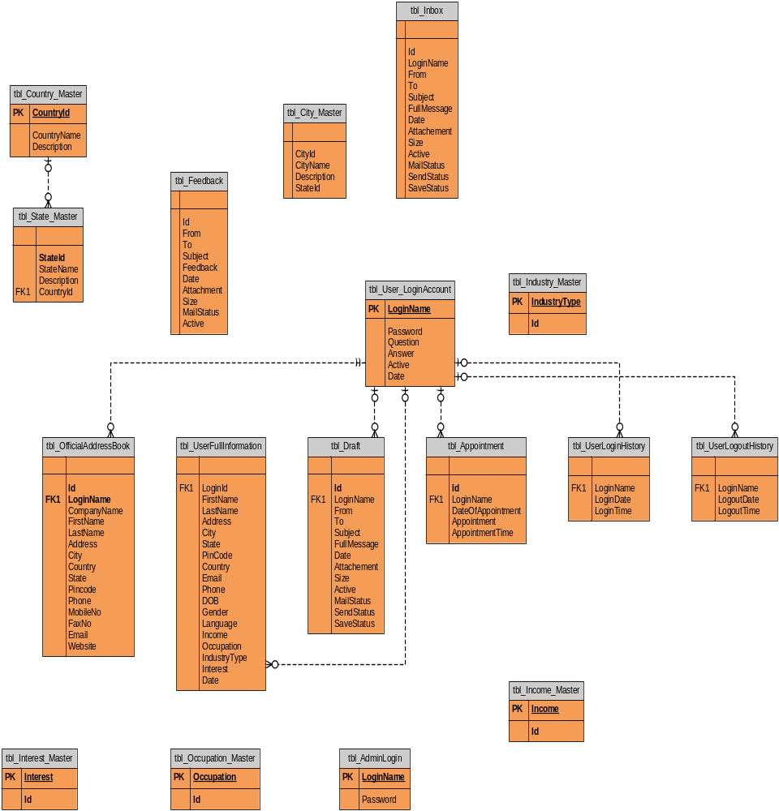
6.4. DATA FLOW DIAGRAMS

A data flow diagram is graphical tool used to describe and analyze movement of data through a system. These are the central tool and the basis from which the other components are developed. The transformation of data from input to output, through processed, may be described logically and independently of physical components associated with the system. These are known as the logical data flow diagrams. The physical data flow diagrams show the actual implements and movement of data between people, departments and workstations. A full description of a system actually consists of a set of data flow diagrams. Using two familiar notations Yourdon, Gane and Sarson notation develops the data flow diagrams. Each component in a DFD is labeled with a descriptive name. Process is further identified with a number that will be used for identification purpose. The development of DFD’S is done in several levels. Each process in lower level diagrams can be broken down into a more detailed DFD in the next level. The lop-level diagram is often called context diagram. It consists a single process bit, which plays vital role in studying the current system. The process in the context level diagram is exploded into other process at the first level DFD.
The idea behind the explosion of a process into more process is that understanding at one level of detail is exploded into greater detail at the next level. This is done until further explosion is necessary and an adequate amount of detail is described for analyst to understand the process.
Larry Constantine first developed the DFD as a way of expressing system requirements in a graphical from, this lead to the modular design.
A DFD is also known as a “bubble Chart” has the purpose of clarifying system requirements and identifying major transformations that will become programs in system design. So it is the starting point of the design to the lowest level of detail. A DFD consists of a series of bubbles joined by data flows in the system.

DFD SYMBOLS:
In the DFD, there are four symbols
- A square defines a source(originator) or destination of system data
- An arrow identifies data flow. It is the pipeline through which the information flows
- A circle or a bubble represents a process that transforms incoming data flow into outgoing data flows.
- An open rectangle is a data store, data at rest or a temporary repository of data

Process that transforms data flow.

Source or Destination of data
Data flow

Data Store

CONSTRUCTING A DFD:
Several rules of thumb are used in drawing DFD’S:

- Process should be named and numbered for an easy reference. Each name should be representative of the process.
- The direction of flow is from top to bottom and from left to right. Data traditionally flow from source to the destination although they may flow back to the source. One way to indicate this is to draw long flow line back to a source. An alternative way is to repeat the source symbol as a destination. Since it is used more than once in the DFD it is marked with a short diagonal.
- When a process is exploded into lower level details, they are numbered.
- The names of data stores and destinations are written in capital letters. Process and dataflow names have the first letter of each work capitalized

A DFD typically shows the minimum contents of data store. Each data store should contain all the data elements that flow in and out.
Questionnaires should contain all the data elements that flow in and out. Missing interfaces redundancies and like is then accounted for often through interviews.

SAILENT FEATURES OF DFD’S
- The DFD shows flow of data, not of control loops and decision are controlled considerations do not appear on a DFD.
- The DFD does not indicate the time factor involved in any process whether the dataflow take place daily, weekly, monthly or yearly.
- The sequence of events is not brought out on the DFD.

TYPES OF DATA FLOW DIAGRAMS
- Current Physical
- Current Logical
- New Logical
- New Physical

CURRENT PHYSICAL:
In Current Physical DFD proecess label include the name of people or their positions or the names of computer systems that might provide some of the overall system-processing label includes an identification of the technology used to process the data. Similarly data flows and data stores are often labels with the names of the actual physical media on which data are stored such as file folders, computer files, business forms or computer tapes.

CURRENT LOGICAL:
The physical aspects at the system are removed as mush as possible so that the current system is reduced to its essence to the data and the processors that transform them regardless of actual physical form.

NEW LOGICAL:
This is exactly like a current logical model if the user were completely happy with he user were completely happy with the functionality of the current system but had problems with how it was implemented typically through the new logical model will differ from current logical model while having additional functions, absolute function removal and inefficient flows recognized.

NEW PHYSICAL:
The new physical represents only the physical implementation of the new system.

RULES GOVERNING THE DFD’S

PROCESS
- No process can have only outputs.
- No process can have only inputs. If an object has only inputs than it must be a sink.
- A process has a verb phrase label.

DATA STORE
- Data cannot move directly from one data store to another data store, a process must move data.
- Data cannot move directly from an outside source to a data store, a process, which receives, must move data from the source and place the data into data store
- A data store has a noun phrase label.

SOURCE OR SINK
The origin and /or destination of data.

- Data cannot move direly from a source to sink it must be moved by a process
- A source and /or sink has a noun phrase land

DATA FLOW
- A Data Flow has only one direction of flow between symbols. It may flow in both directions between a process and a data store to show a read before an update. The later is usually indicated however by two separate arrows since these happen at different type.
- A join in DFD means that exactly the same data comes from any of two or more different processes data store or sink to a common location.
- A data flow cannot go directly back to the same process it leads. There must be at least one other process that handles the data flow produce some other data flow returns the original data into the beginning process.
- A Data flow to a data store means update (delete or change).
- A data Flow from a data store means retrieve or use.

A data flow has a noun phrase label more than one data flow noun phrase can appear on a single arrow as long as all of the flows on the same arrow move together as one package.

CONTEXT DIAGRAM

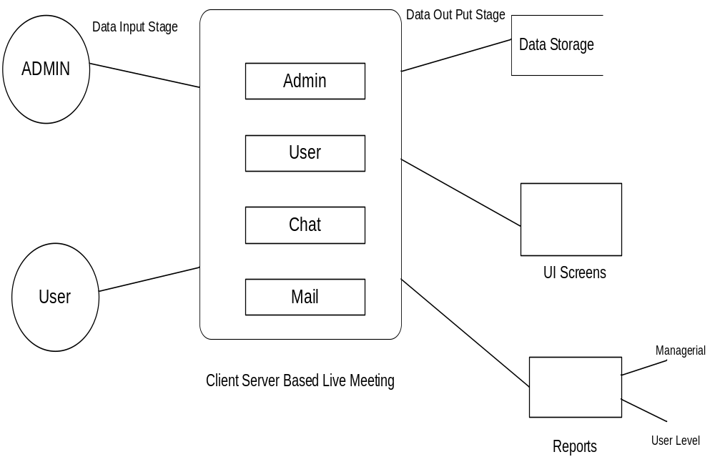

Login DFD

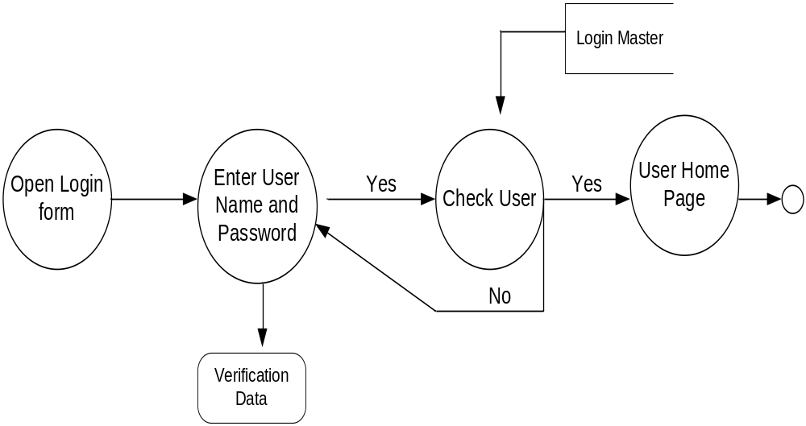
Admin Activities (1st Level)

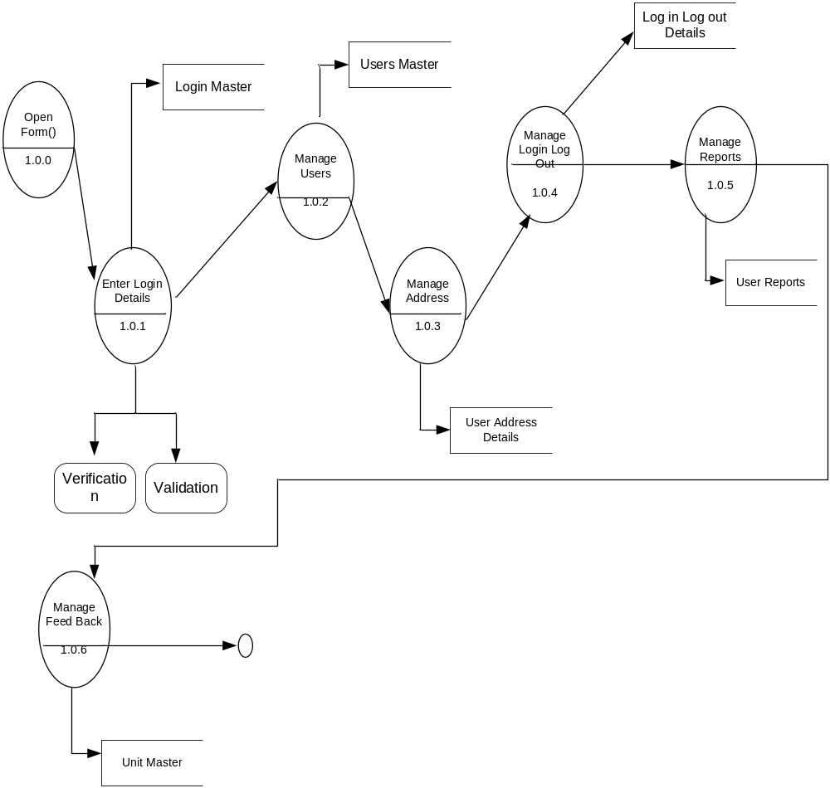

Admin Manage Country, State, City, Income and Occupation Details

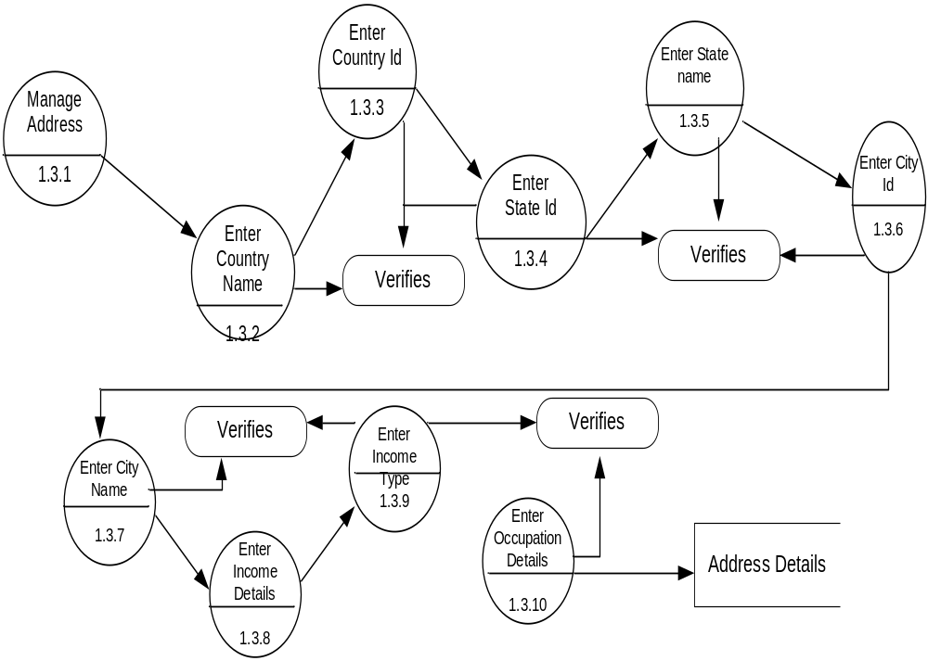

Admin Mange Users

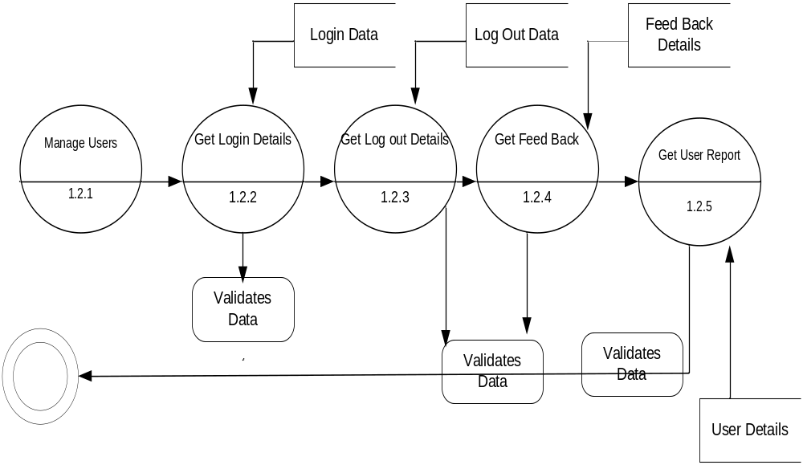
User Activities (2nd Level)

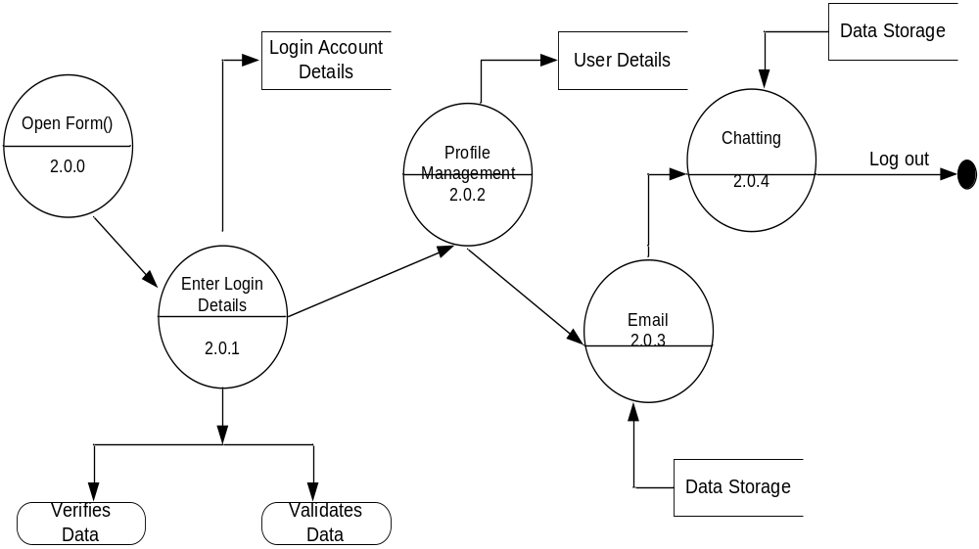

Unified Modeling Language Diagrams
  - The unified modeling language allows the software engineer to express an analysis model using the modeling notation that is governed by a set of syntactic semantic and pragmatic rules.
  - A UML system is represented using five different views that describe the system from distinctly different perspective. Each view is defined by a set of diagram, which is as follows.
  - User Model View
    - This view represents the system from the users perspective.
    - The analysis representation describes a usage scenario from the end-users perspective.
  - Structural model view
◆ In this model the data and functionality are arrived from inside the system.
◆ This model view models the static structures.
  - Behavioral Model View
◆ It represents the dynamic of behavioral as parts of the system, depicting the interactions of collection between various structural elements described in the user model and structural model view.
  - Implementation Model View
  - In this the structural and behavioral as parts of the system are represented as they are to be built.
Environmental Model View
In this the structural and behavioral aspects of the environment in which the system is to be implemented are represented.
UML is specifically constructed through two different domains they are
  - UML Analysis modeling, which focuses on the user model and structural model views of the system
  - UML design modeling, which focuses on the behavioral modeling, implementation modeling and environmental model views.

INTRODUCTION TO THE UNIFIED MODIFIED LANGUAGE
Building a model for a software system prior to its construction is as essential as having a blueprint for building a large building. Good models are essential for communication among project teams. As the complexity of the systems increases, so does the importance of good modeling techniques.

A modeling language must include:

- Model elements- fundamentally modeling concepts and semantics.

Notation-visual rendering of model elements

Guidelines-expression of usage within trade

The use of visual notation to represent or model a problem can provide us several benefits relating to clarity, familiarity, maintenance, and simplification. The main reason for modeling is the reduction of complexity.

The Unified Modeling Language (UML) is a set of notations and conventions used to describe and model an application. The UML is intended to be a universal language for modeling systems, meaning that it can express models of many different kinds and purposes, just as a programming language or a natural language can be used in different ways.

A “model” is an abstract representation of a system , constructed to understand the system prior to building or modifying it. The term “system” is used here in a broad sense to include any process or structure. For example, the organizational structure of a corporation , health services, computer software, instruction of any sort (including computers) , the national economy, and so forth all would be termed “systems”.

The unified modeling language is a language for specifying, constructing, visualizing, and documenting the software system and its components. The UML is a graphical language with sets of rules and semantics. The rules and semantics of a model are expressed in English, in a form known as “object constraint language”(OCL).OCL is a specification language that uses simple logic for specifying the properties of a system.

The UML is not intended to be a visual programming language in the sense of having all the necessary visual and semantic support to replace programming languages. However, the UML does have a tight mapping to a family of object-oriented languages, so that you can get the best of both worlds.

The primary goals in the design of the UML were as follows:

- Provide users ready-to-use, expensive visual modeling languages so they can develop and exchange meaningful models.

- Provide extendibility and specialization mechanisms to extend the core concepts.

- Be independent of particular programming languages and development process.

- Provide a formal basis for understanding the modeling language.

- Encourage the growth of the OO tools market.

- Support higher level development concepts.

- Integrate best practices and methodologies.

UML is a language used to:

- “Visualize” the software system well-defined symbols. Thus a developer or tool can unambiguously interpret a model written by another developer, using UML
- “Specify the software system and help building precise, unambiguous and complete models.
- “Construct” the models of the software system that can directly communicate with a variety of programming languages.
- “Document” models of the software system during its development stages.

Architectural views and diagrams of the UML

The UML Meta model elements are organized into diagrams. Different diagrams are used for
different purposes depending on the angle from which you are viewing the system. The different views are called “architectural views”. Architectural views facilitate the organization of knowledge, and diagrams enable the communication of knowledge. Then knowledge itself is within the model or set of models that focuses on the problem and solution. The architectural views and their diagrams are summarized below:

- The “user model view” encompasses a problem and solution from the preservative of those individuals whose problem the solution addresses. The view presents the goals and objectives of the problem owners and their requirements of the solution. This view is composed of “use case diagrams”. These diagrams describe the functionality provided by a system to external interactors. These diagrams contain actors, use cases, and their relationships.

  - “Class diagrams” describe the static structure of a system, or how it is declared rather than how it behaves. These diagrams contain classes and associations.
  - “object diagrams” describe the static structure of a system at a particular time during its life. These diagrams contain objects and links.

- The “behavioral model view” encompasses the dynamic or behavioral aspects of a problem and solution. The view is also known as the dynamic, process, concurrent or collaborative view. This view is composed of the following diagrams:

- “Sequence diagrams” render the specification of behavior. These diagrams describes the behavior provided by a system to interactors. These diagrams contain classes that exchange messages with in an interaction arranged in time sequence. In generic form, These diagrams describe a set of message exchange sequences among a set of classes. In instance form(scenarios), these diagrams describe one actual message exchange sequence among objects of those classes.
- “Collaboration diagrams” render how behavior is realized by components with in a system. These diagrams contain classes, associations, and their message exchanges with in a collaboration to accomplish a purpose. In generic form, these diagrams describe a set of classes and associations involved in message exchange sequences. In instance form(scenarios), these diagrams describe a set of objects of those classes links confirming to the associations, and one actual message exchange sequence that inconsistent with the generic form and uses those objects and links.
- “State chart diagrams” render the states and responses of a class participating in behavior, and the life cycle of an object. These diagrams describe the behavior of a class in response to external stimuli.
- “Activity diagrams” render the activities of a class participating in behavior. These diagrams describe the behavior of a class in response to internal processing rather than external events. Activity diagrams describe the processing activities with in a class.
- The “Implementation model view” encompasses the structural and behavioral aspects of the solution’s realization. This view is also known as the component or development view and is composed of “component diagrams”. These diagrams describe the organization of and dependencies among software implementation components. These diagrams contain components and their relationships.
- The “Environment model view” encompasses the structural and behavioral aspects of the domain in which a solution must be realized. This view is also known as the deployment or physical view. This view is composed of “deployment diagrams”. These diagrams describe the configuration of processing resources elements and the mapping of software implementation components onto them. These diagrams contain nodes, components and their relationships.

UML DIAGRAMS

Every complex system is best approached through a small set of nearly independent views of a model; no single viewer is sufficient. Every model may be expressed at different levels of fidelity. The best models are connected to reality. The UML defines nine graphical diagrams.

- Class diagram
- Use-case diagram
3. Sequence diagram
4. Collaboration diagram
5. Activity diagram
Administrator Functionalities

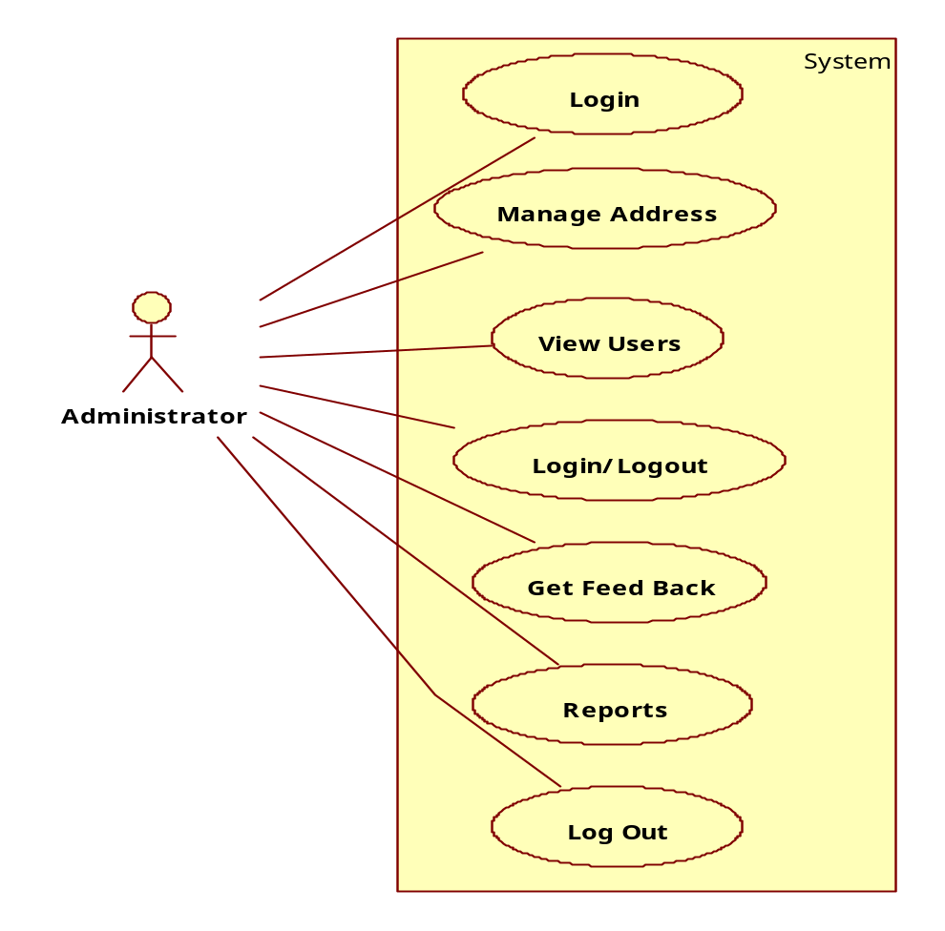
User Activities

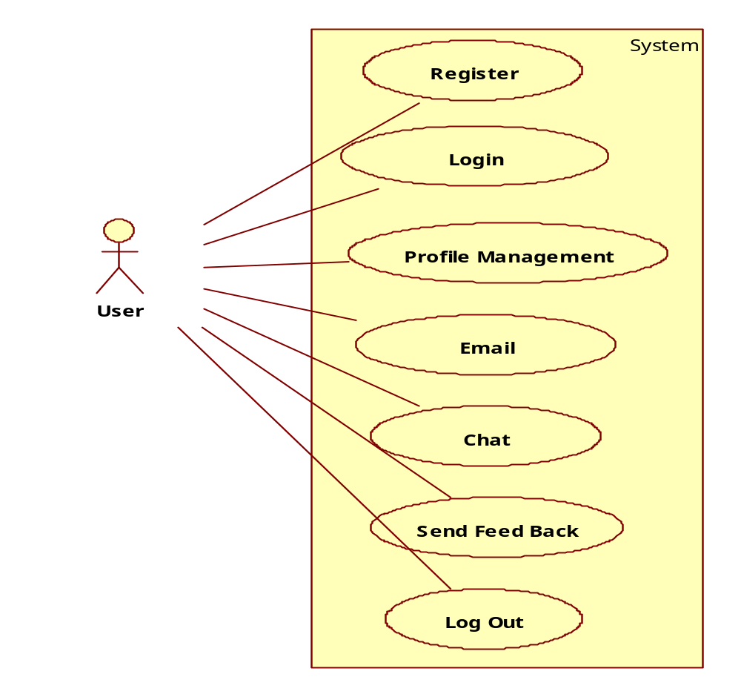
Sequence Diagrams

Admin Login

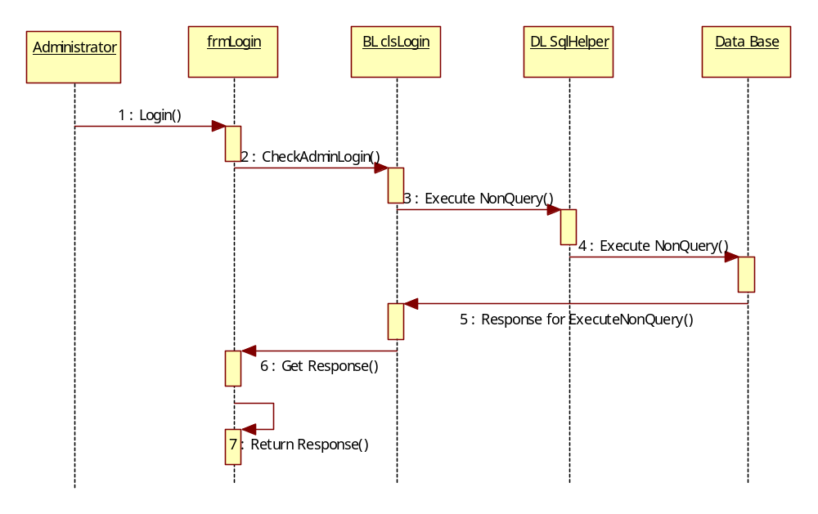
Admin Add New Country Details

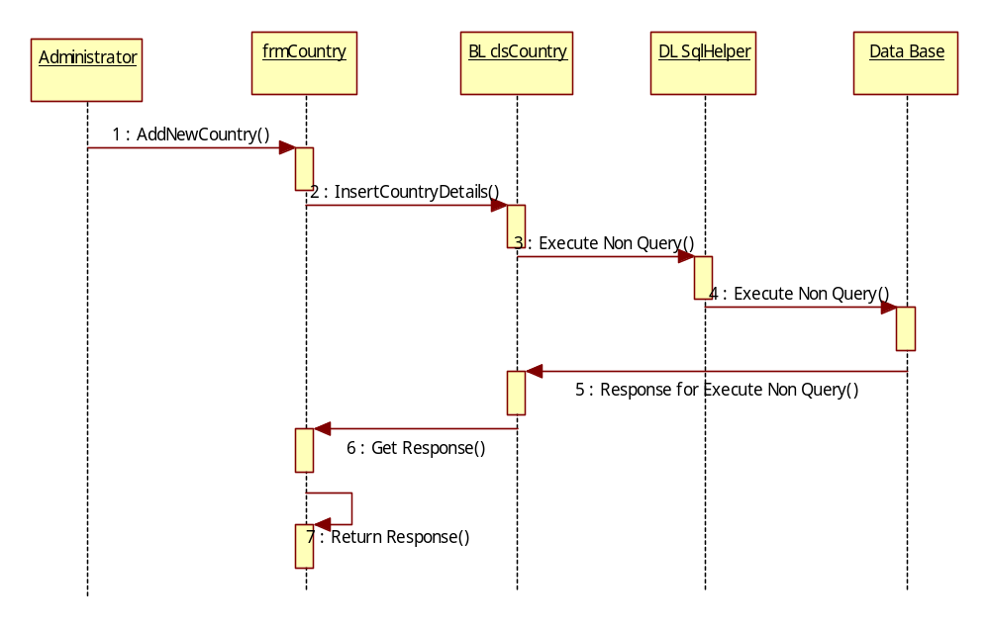
Admin Add New State Details
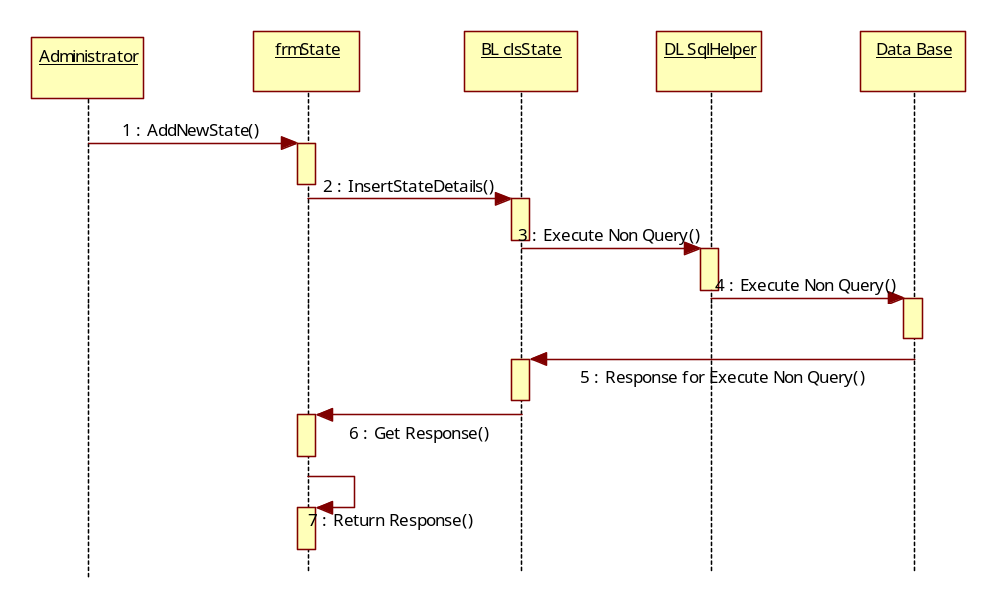
Admin Track User Login Details

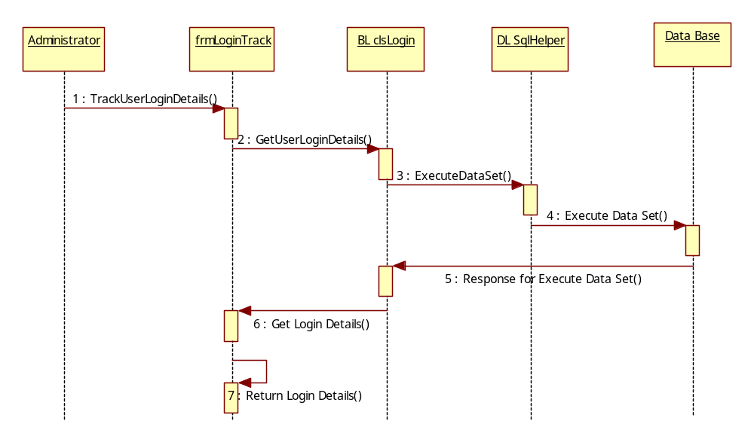
Admin Track User Log Out Details
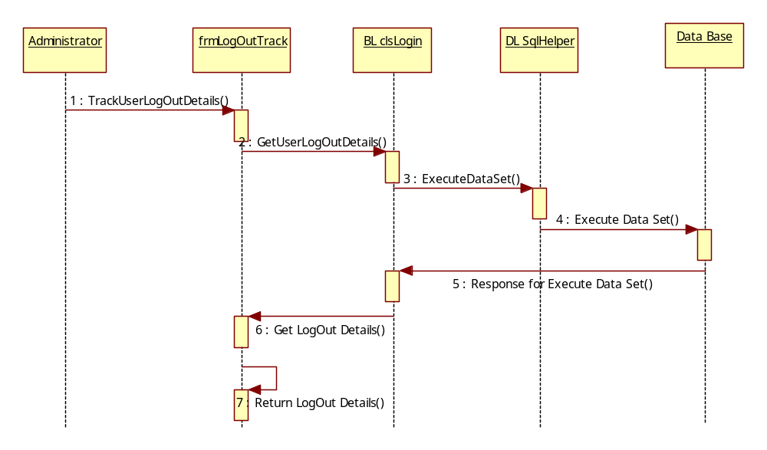
User Login
User
Login
BL Login
Data Base
DL SQlHelper
1 : Login()
2 : Validate Data()
5 : Response for Execute NonQuery()
7 : Show Result
3 : Execute NonQuery()
4 : Execute NonQuery()
6 : Get Response

User Activities

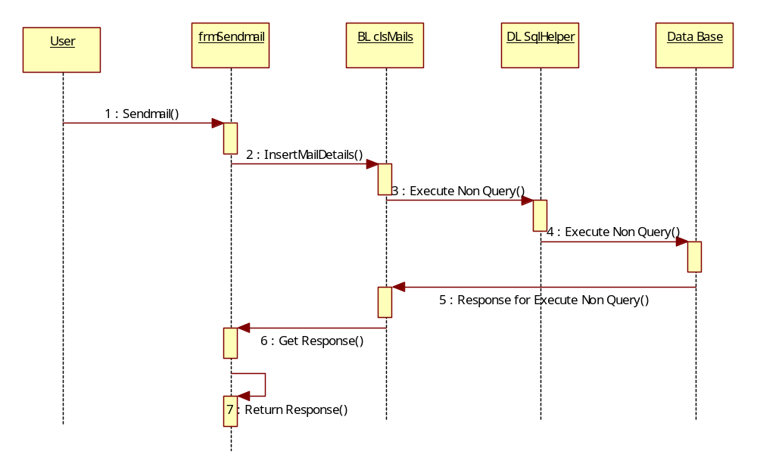
User Chat Details
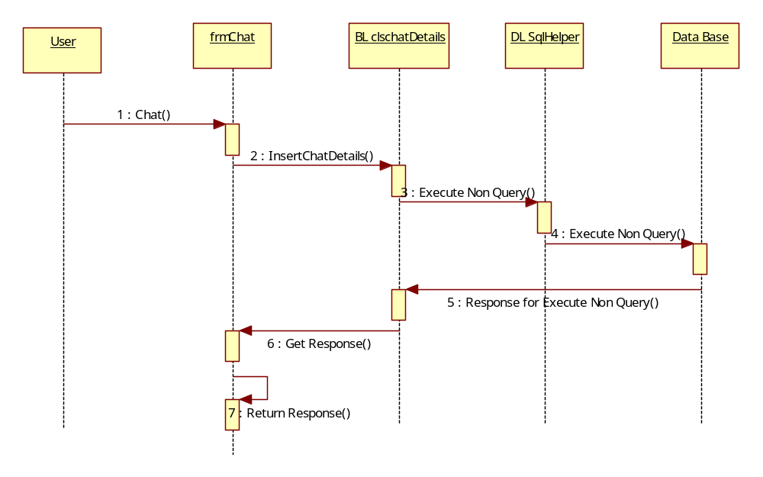
Collaboration Diagrams

Admin Login

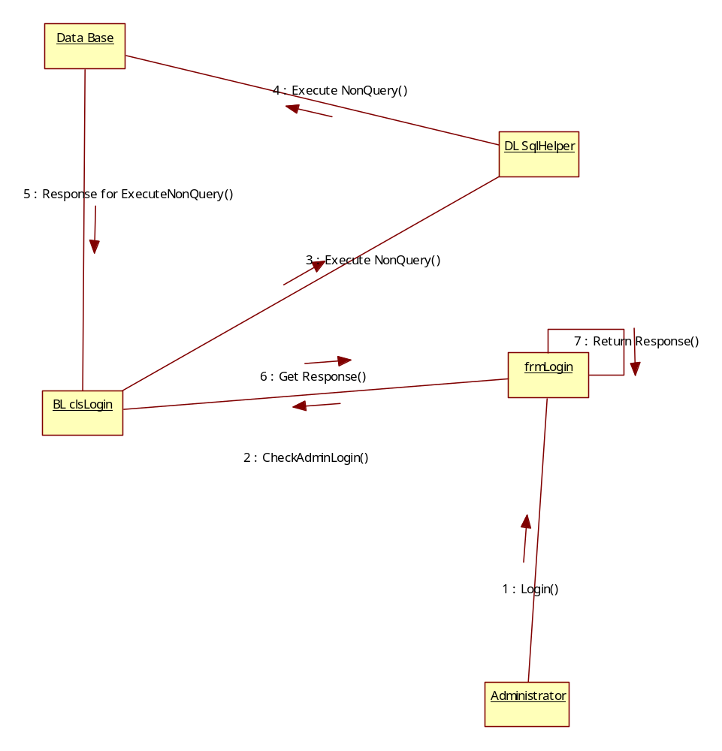
Admin Add New Country Details

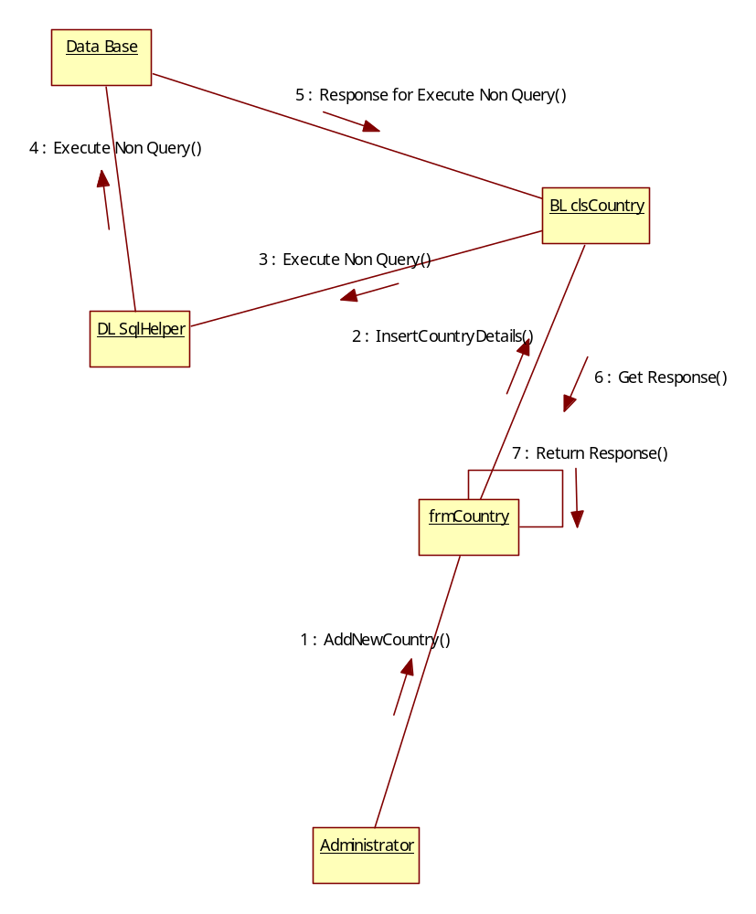
Admin Add New State Details
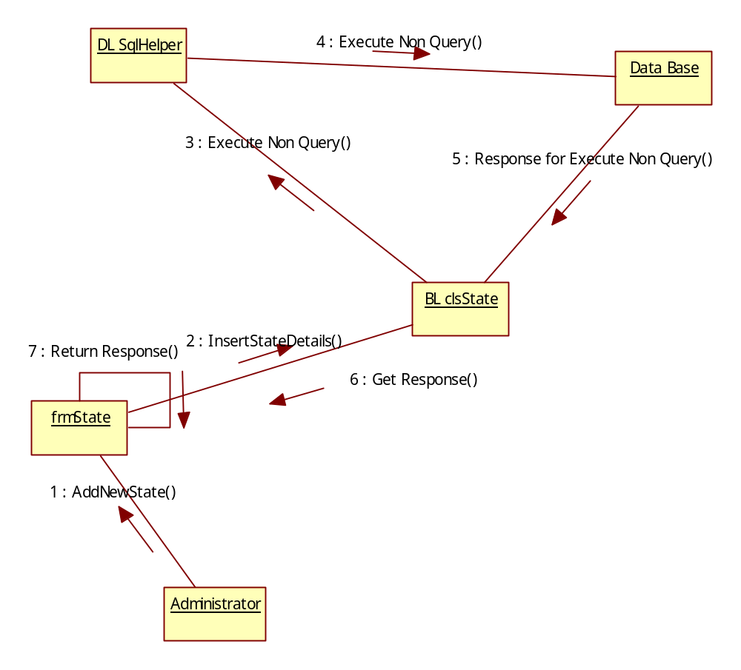
Admin Track User Login Details

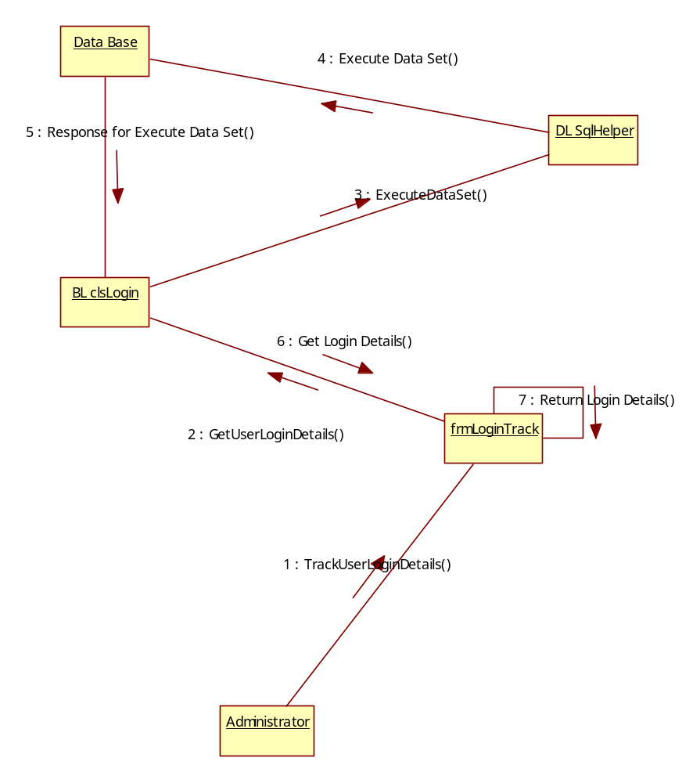
Admin Track User Log Out Details
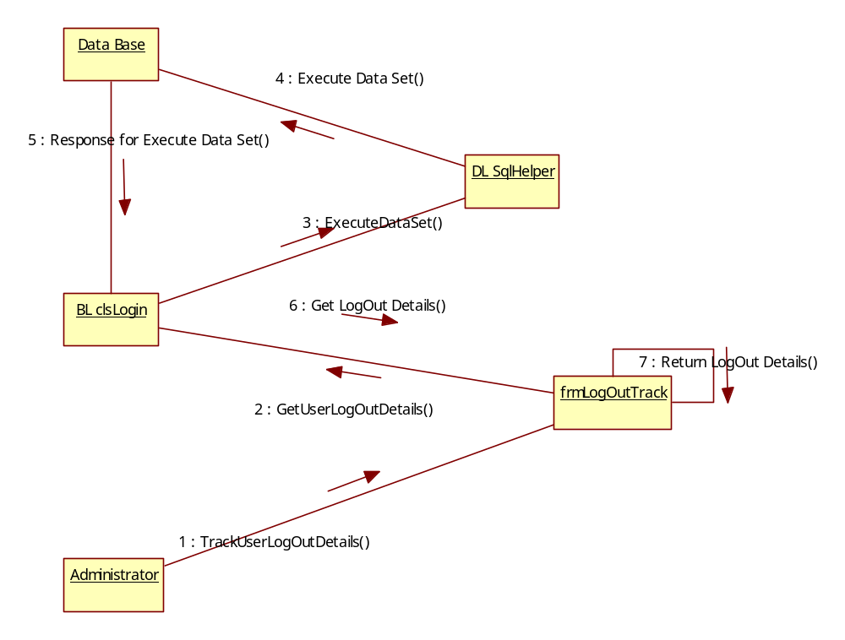

User Login

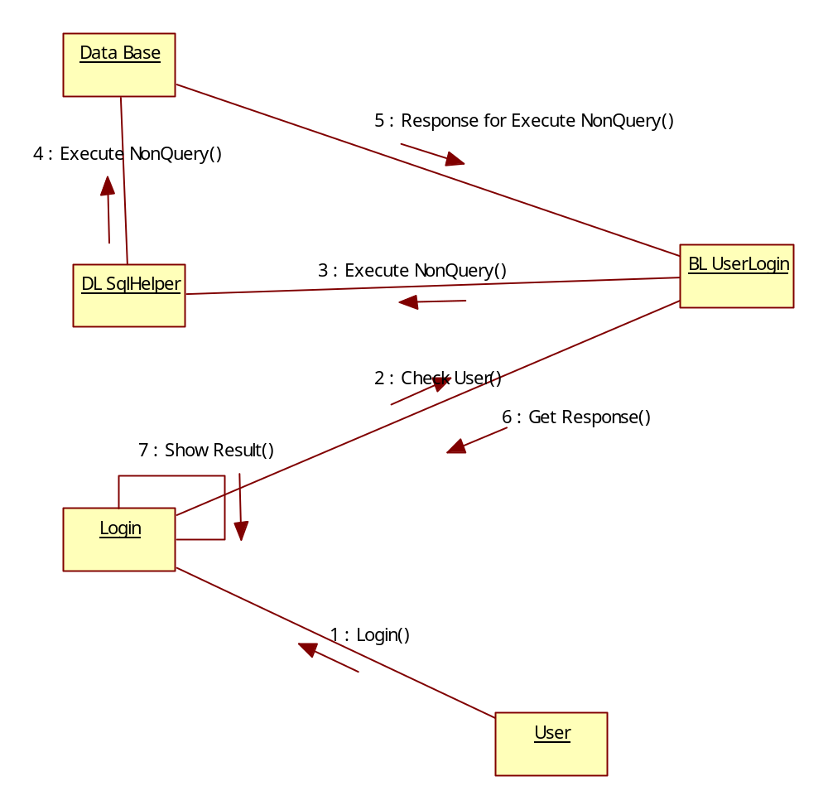
User Chat Details
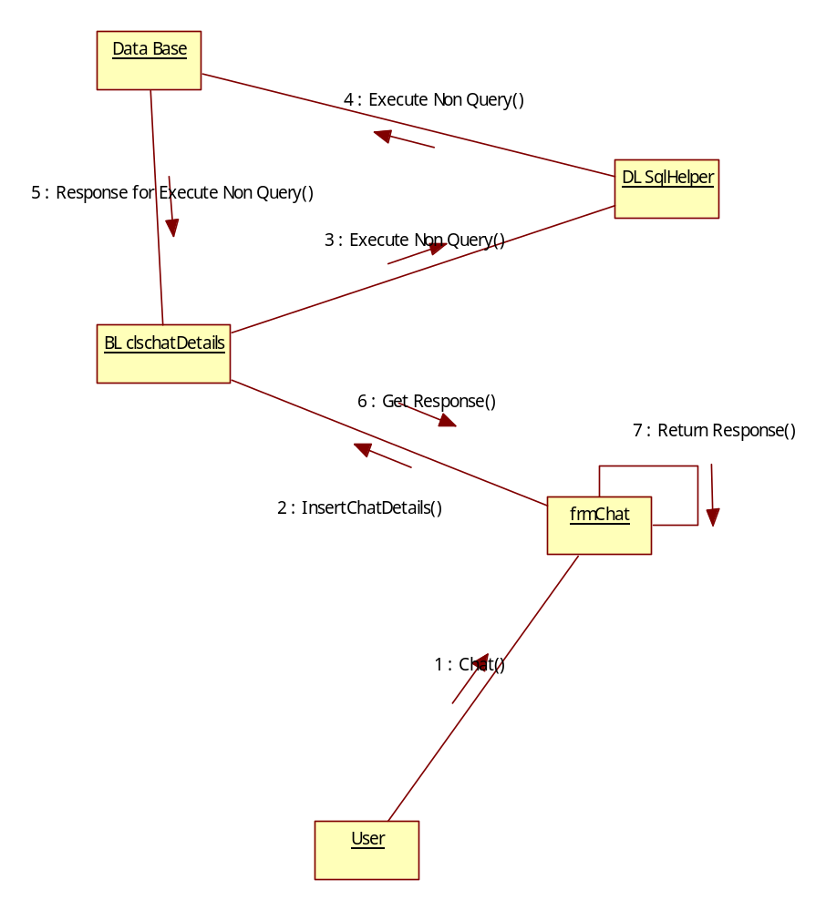

Client Server Based Live Meeting Activity Diagrams
User Registration Activity

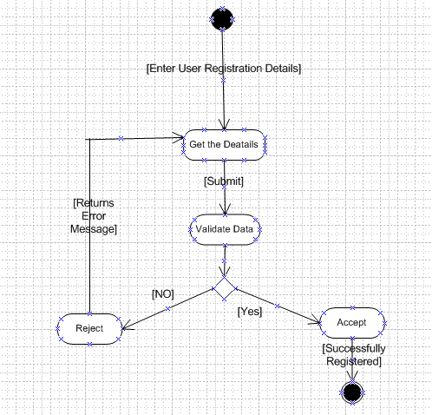
Login Activity:

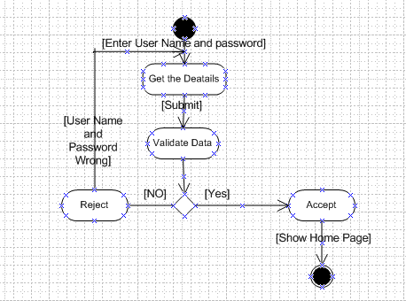

Admin Activities
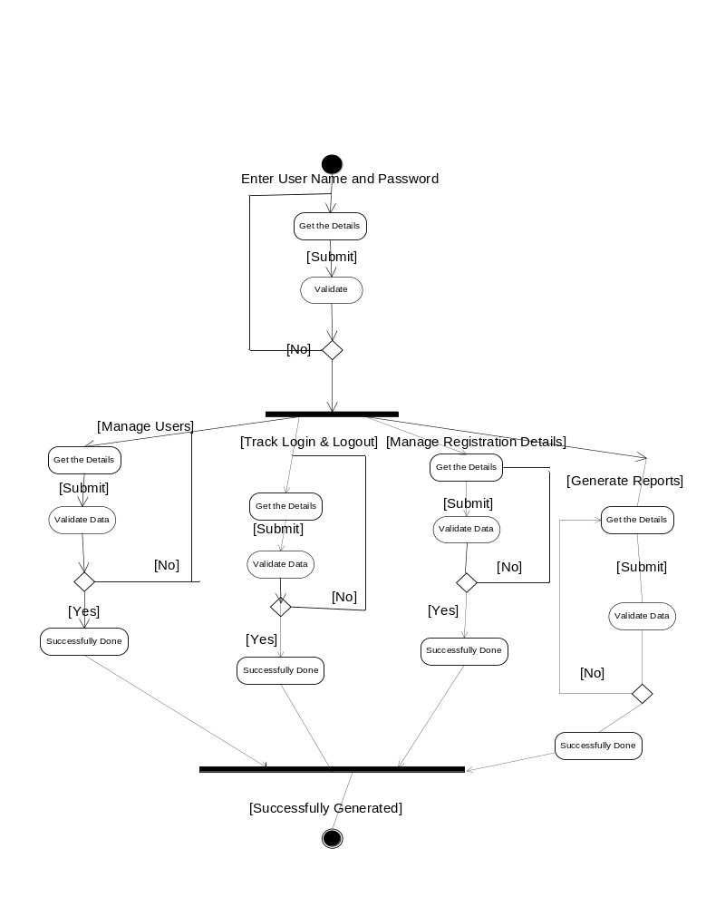
User Activities

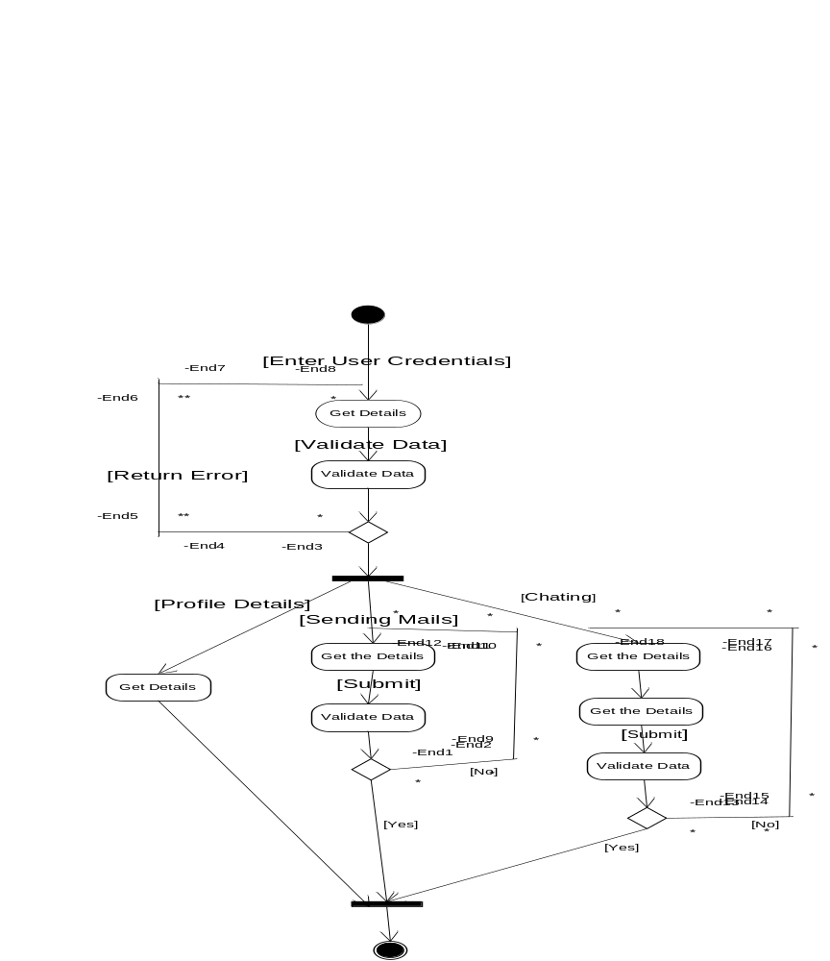

Admin User Login Logout Details
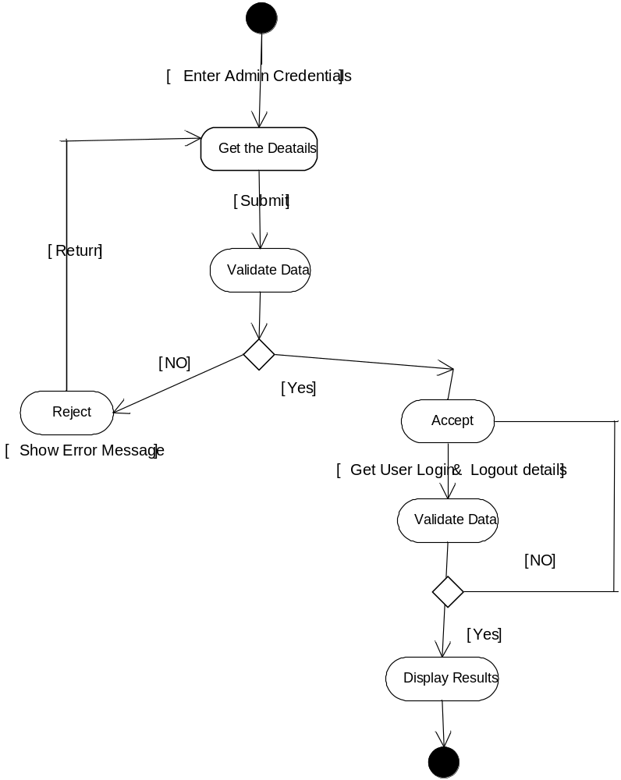

Admin User Details Report
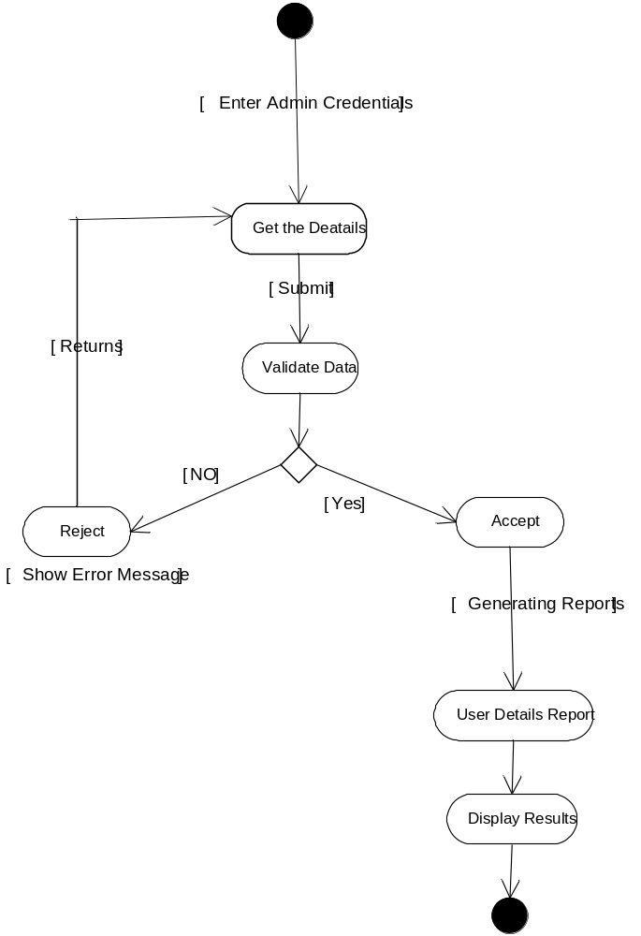
Class Diagrams

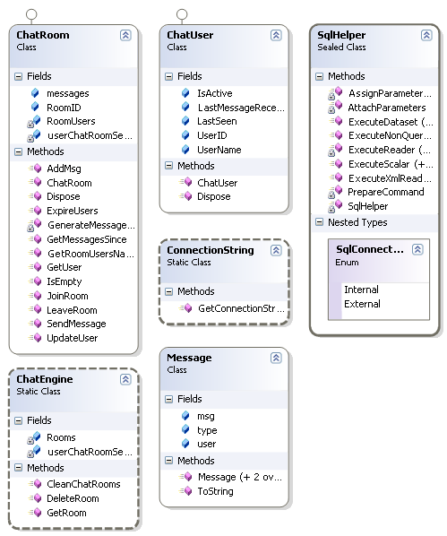
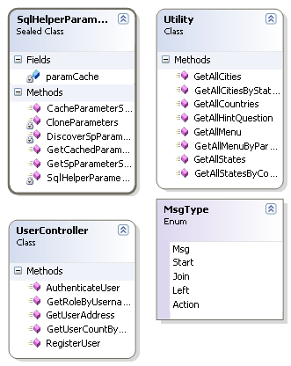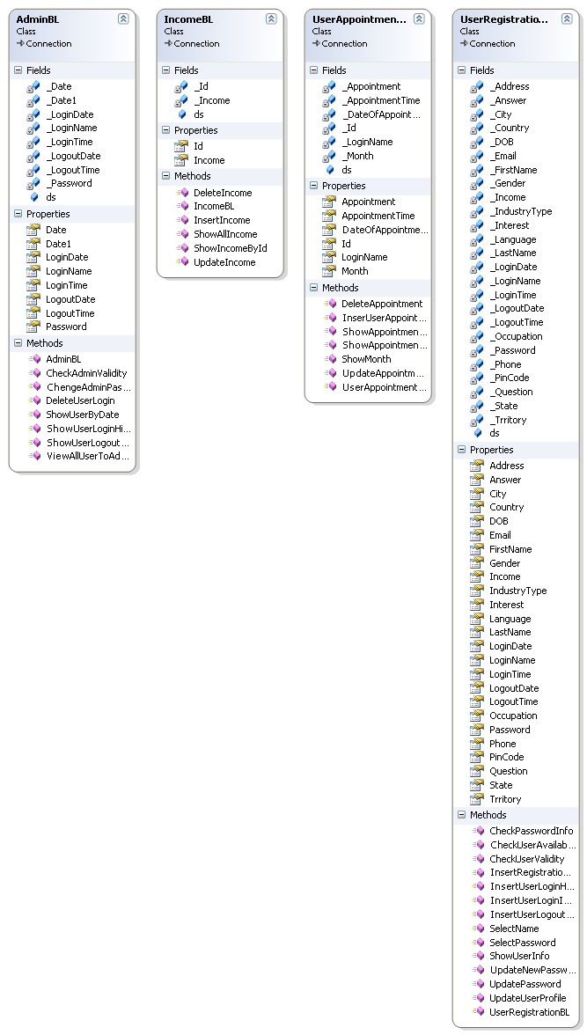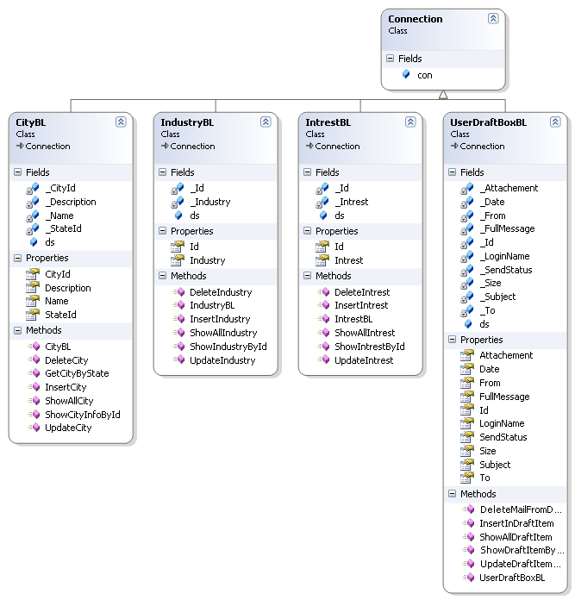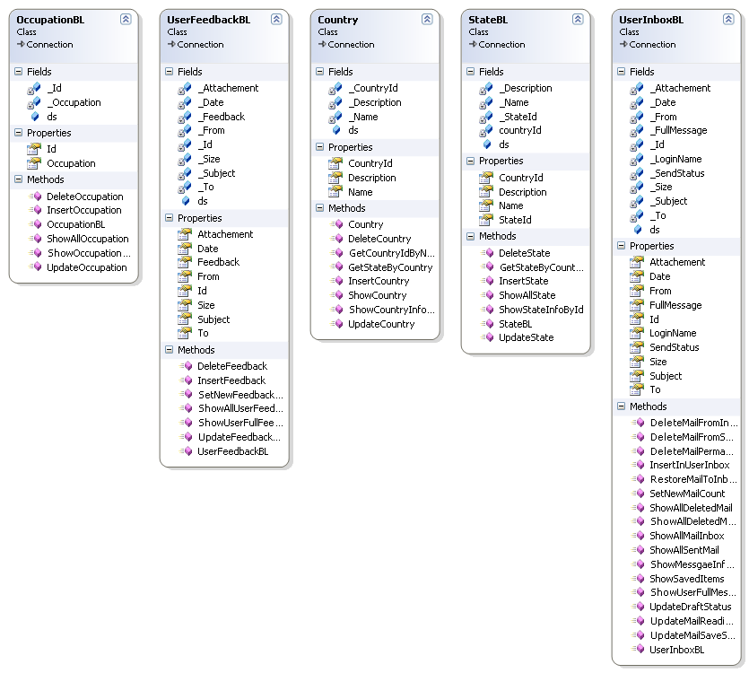

Deployment Diagrams

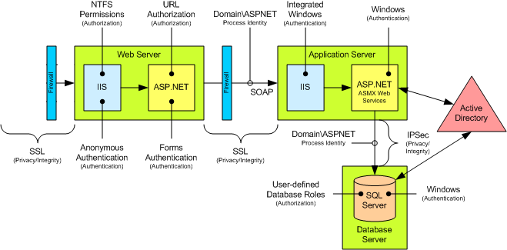

Chapter 7
(Paste Your Output Screens)

SYSTEM TESTING AND IMPLEMENTATION

8.1. INTRODUCTION
Software testing is a critical element of software quality assurance and represents the ultimate review of specification, design and coding. In fact, testing is the one step in the software engineering process that could be viewed as destructive rather than constructive.
A strategy for software testing integrates software test case design methods into a well-planned series of steps that result in the successful construction of software. Testing is the set of activities that can be planned in advance and conducted systematically. The underlying motivation of program testing is to affirm software quality with methods that can economically and effectively apply to both strategic to both large and small-scale systems.

8.2. STRATEGIC APPROACH TO SOFTWARE TESTING
The software engineering process can be viewed as a spiral. Initially system engineering defines the role of software and leads to software requirement analysis where the information domain, functions, behavior, performance, constraints and validation criteria for software are established. Moving inward along the spiral, we come to design and finally to coding. To develop computer software we spiral in along streamlines that decrease the level of abstraction on each turn.

A strategy for software testing may also be viewed in the context of the spiral. Unit testing begins at the vertex of the spiral and concentrates on each unit of the software as implemented in source code. Testing progress by moving outward along the spiral to integration testing, where the focus is on the design and the construction of the software architecture. Talking another turn on outward on the spiral we encounter validation testing where requirements established as part of software requirements analysis are validated against the software that has been constructed. Finally we arrive at system testing, where the software and other system elements are tested as a whole.

UNIT TESTING

MODULE TESTING

SUB-SYSTEM TESING

SYSTEM TESTING

ACCEPTANCE TESTING
Component Testing
Integration Testing
User Testing

8.3. Unit Testing
Unit testing focuses verification effort on the smallest unit of software design, the module. The unit testing we have is white box oriented and some modules the steps are conducted in parallel.
1. WHITE BOX TESTING
This type of testing ensures that
- All independent paths have been exercised at least once
- All logical decisions have been exercised on their true and false sides
- All loops are executed at their boundaries and within their operational bounds
- All internal data structures have been exercised to assure their validity.

To follow the concept of white box testing we have tested each form .we have created independently to verify that Data flow is correct, All conditions are exercised to check their validity, All loops are executed on their boundaries.

2. BASIC PATH TESTING
Established technique of flow graph with Cyclomatic complexity was used to derive test cases for all the functions. The main steps in deriving test cases were:
Use the design of the code and draw correspondent flow graph.
Determine the Cyclomatic complexity of resultant flow graph, using formula:

V(G)=E-N+2 or
V(G)=P+1 or
V(G)=Number Of Regions

Where V(G) is Cyclomatic complexity,
E is the number of edges,
N is the number of flow graph nodes,
P is the number of predicate nodes.
Determine the basis of set of linearly independent paths.

3. CONDITIONAL TESTING
In this part of the testing each of the conditions were tested to both true and false aspects. And all the resulting paths were tested. So that each path that may be generate on particular condition is traced to uncover any possible errors.

4. DATA FLOW TESTING
This type of testing selects the path of the program according to the location of definition and use of variables. This kind of testing was used only when some local variable were declared. The definition-use chain method was used in this type of testing. These were particularly useful in nested statements.

5. LOOP TESTING
In this type of testing all the loops are tested to all the limits possible. The following exercise was adopted for all loops:
- All the loops were tested at their limits, just above them and just below them.
- All the loops were skipped at least once.
- For nested loops test the inner most loop first and then work outwards.
- For concatenated loops the values of dependent loops were set with the help of connected loop.
- Unstructured loops were resolved into nested loops or concatenated loops and tested as above.

Each unit has been separately tested by the development team itself and all the input have been validated.

Chapter 9

System Security

9.1. Introduction
The protection of computer based resources that includes hardware, software, data, procedures and people against unauthorized use or natural
Disaster is known as System Security.

System Security can be divided into four related issues:
- Security
- Integrity
- Privacy
- Confidentiality

SYSTEM SECURITY refers to the technical innovations and procedures applied to the hardware and operation systems to protect against deliberate or accidental damage from a defined threat.

DATA SECURITY is the protection of data from loss, disclosure, modification and destruction.

SYSTEM INTEGRITY refers to the power functioning of hardware and programs, appropriate physical security and safety against external threats such as eavesdropping and wiretapping.

PRIVACY defines the rights of the user or organizations to determine what information they are willing to share with or accept from others and how the organization can be protected against unwelcome, unfair or excessive dissemination of information about it.

CONFIDENTIALITY is a special status given to sensitive information in a database to minimize the possible invasion of privacy. It is an attribute of information that characterizes its need for protection.

9.2. SECURITY IN SOFTWARE

System security refers to various validations on data in form of checks and controls to avoid the system from failing. It is always important to ensure that only valid data is entered and only valid operations are performed on the system. The system employees two types of checks and controls:
CLIENT SIDE VALIDATION
Various client side validations are used to ensure on the client side that only valid data is entered. Client side validation saves server time and load to handle invalid data. Some checks imposed are:
- VBScript in used to ensure those required fields are filled with suitable data only. Maximum lengths of the fields of the forms are appropriately defined.
- Forms cannot be submitted without filling up the mandatory data so that manual mistakes of submitting empty fields that are mandatory can be sorted out at the client side to save the server time and load.
- Tab-indexes are set according to the need and taking into account the ease of user while working with the system.

SERVER SIDE VALIDATION
Some checks cannot be applied at client side. Server side checks are necessary to save the system from failing and intimating the user that some invalid operation has been performed or the performed operation is restricted. Some of the server side checks imposed is:
- Server side constraint has been imposed to check for the validity of primary key and foreign key. A primary key value cannot be duplicated. Any attempt to duplicate the primary value results into a message intimating the user about those values through the forms using foreign key can be updated only of the existing foreign key values.
- User is intimating through appropriate messages about the successful operations or exceptions occurring at server side.
- Various Access Control Mechanisms have been built so that one user may not agitate upon another. Access permissions to various types of users are controlled according to the organizational structure. Only permitted users can log on to the system and can have access according to their category. User- name, passwords and permissions are controlled o the server side.
- Using server side validation, constraints on several restricted operations are imposed.

Chapter 10

CONCLUSION

It has been a great pleasure for me to work on this exciting and challenging project. This project proved good for me as it provided practical knowledge of not only programming in ASP.NET and VB.NET/C#.NET web based application and no some extent Windows Application and SQL Server, but also about all handling procedure related with “Client Server Based Live Meeting”. It also provides knowledge about the latest technology used in developing web enabled application and client server technology that will be great demand in future. This will provide better opportunities and guidance in future in developing projects independently.
BENEFITS:
The project is identified by the merits of the system offered to the user. The merits of this project are as follows: -
- It’s a web-enabled project.
- This project offers user to enter the data through simple and interactive forms. This is very helpful for the client to enter the desired information through so much simplicity.
- The user is mainly more concerned about the validity of the data, whatever he is entering. There are checks on every stages of any new creation, data entry or updation so that the user cannot enter the invalid data, which can create problems at later date.
- Sometimes the user finds in the later stages of using project that he needs to update some of the information that he entered earlier. There are options for him by which he can update the records. Moreover there is restriction for him that he cannot change the primary data field. This keeps the validity of the data to longer extent.
- User is provided the option of monitoring the records he entered earlier. He can see the desired records with the variety of options provided by him.
- From every part of the project the user is provided with the links through framing so that he can go from one option of the project to other as per the requirement. This is bound to be simple and very friendly as per the user is concerned. That is, we can see that the project is user friendly which is one of the primary concerns of any good project.
- Data storage and retrieval will become faster and easier to maintain because data is stored in a systematic manner and in a single database.
- Decision making process would be greatly enhanced because of faster processing of information since data collection from information available on computer takes much less time then manual system.
- Allocating of sample results becomes much faster because at a time the user can see the records of last years.
- Easier and faster data transfer through latest technology associated with the computer and communication.
- Through these features it will increase the efficiency, accuracy and transparency,

LIMITATIONS:
- The size of the database increases day-by-day, increasing the load on the database back up and data maintenance activity.
- Training for simple computer operations is necessary for the users working on the system.

Chapter 11

BIBLIOGRAPHY

- FOR .NET INSTALLATION
www.support.mircosoft.com
- FOR DEPLOYMENT AND PACKING ON SERVER
www.developer.com
www.15seconds.com
- FOR SQL
www.msdn.microsoft.com
- FOR ASP.NET
www.msdn.microsoft.com/net/quickstart/aspplus/default.com
www.asp.net
www.fmexpense.com/quickstart/aspplus/default.com
www.asptoday.com
www.aspfree.com
www.4guysfromrolla.com/index.aspx

